

**Practical No: 01 Aim:** Configuring WEP on a Wireless Router

**Components:** Wireless Router, Router, Switch, Device (PC)

**Theory:** Wired Equivalent Privacy (WEP) is a security protocol, specified in the IEEE Wireless Fidelity (Wi-Fi) standard, 802.11b. That standard is designed to provide a wireless local area network (WLAN) with a level of security and privacy comparable to what is usually expected of a wired LAN.

# Cisco Packet Tracer Setup:-

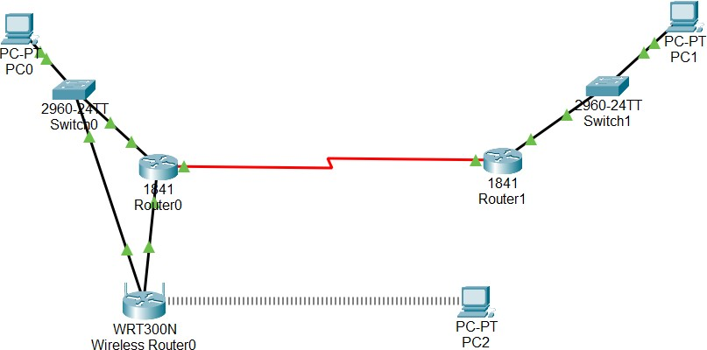

**Implementation:**

**Step 1:** Arranging devices

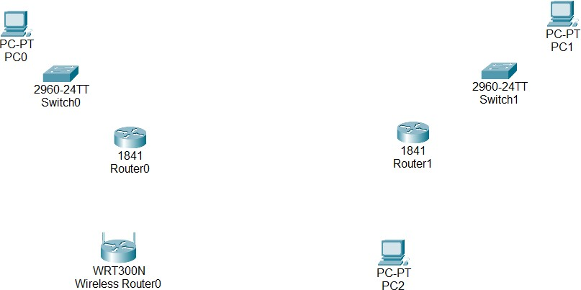

**Step 2:** Creating connections using Ethernet and serial cable between devices



**Step 3:** Configuring all devices

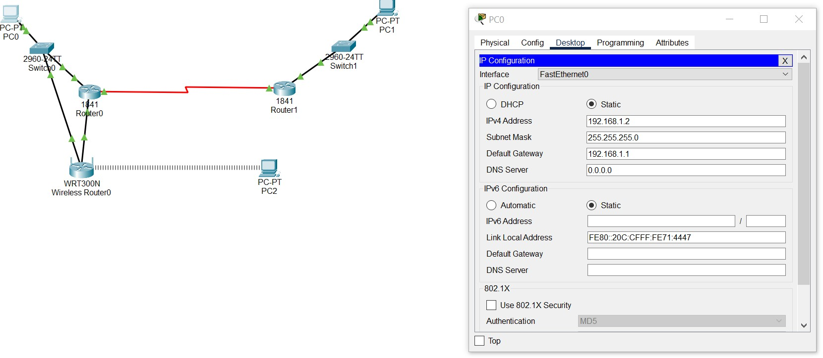

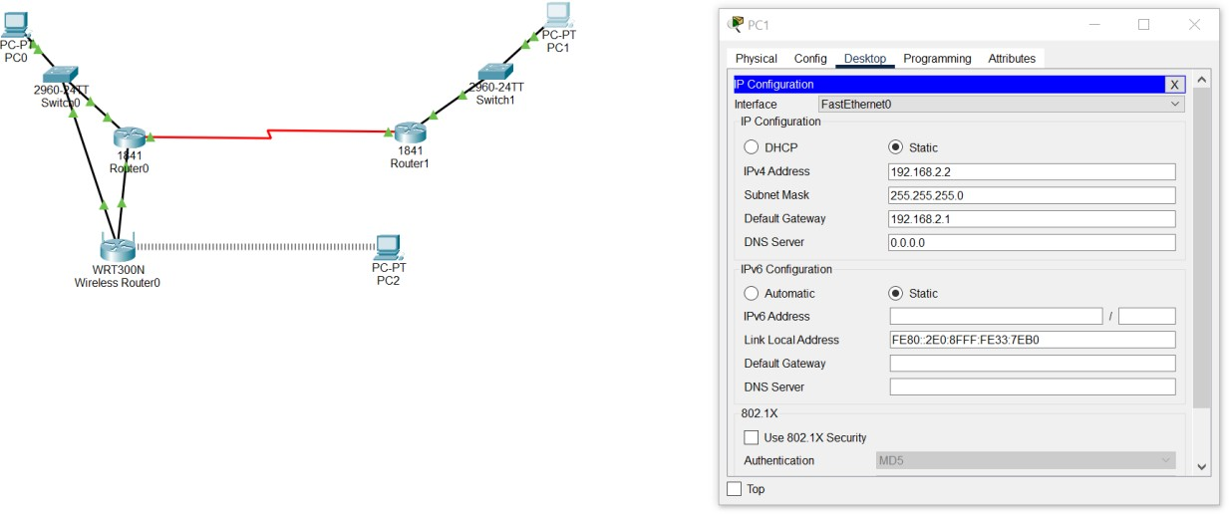

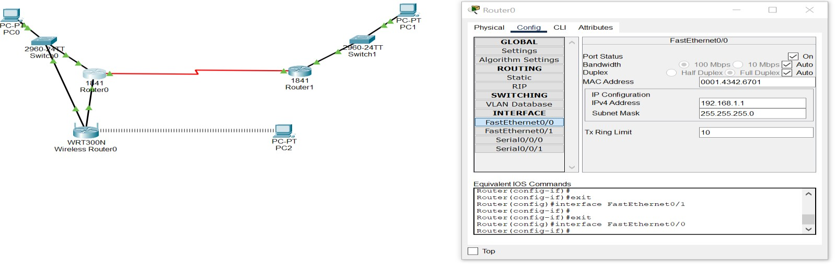

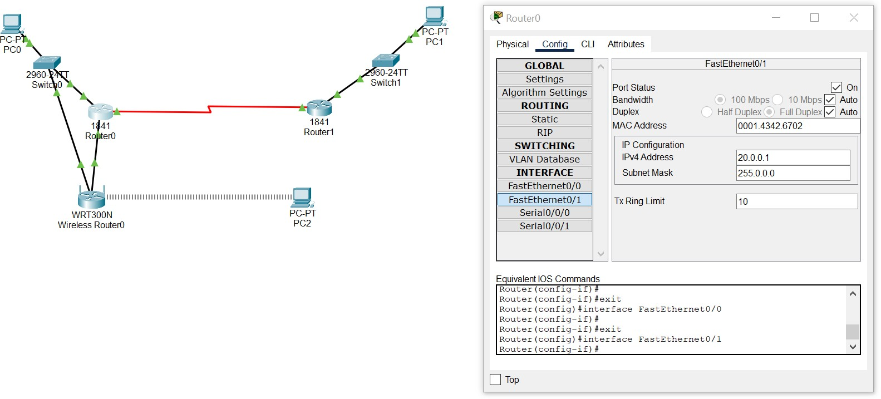

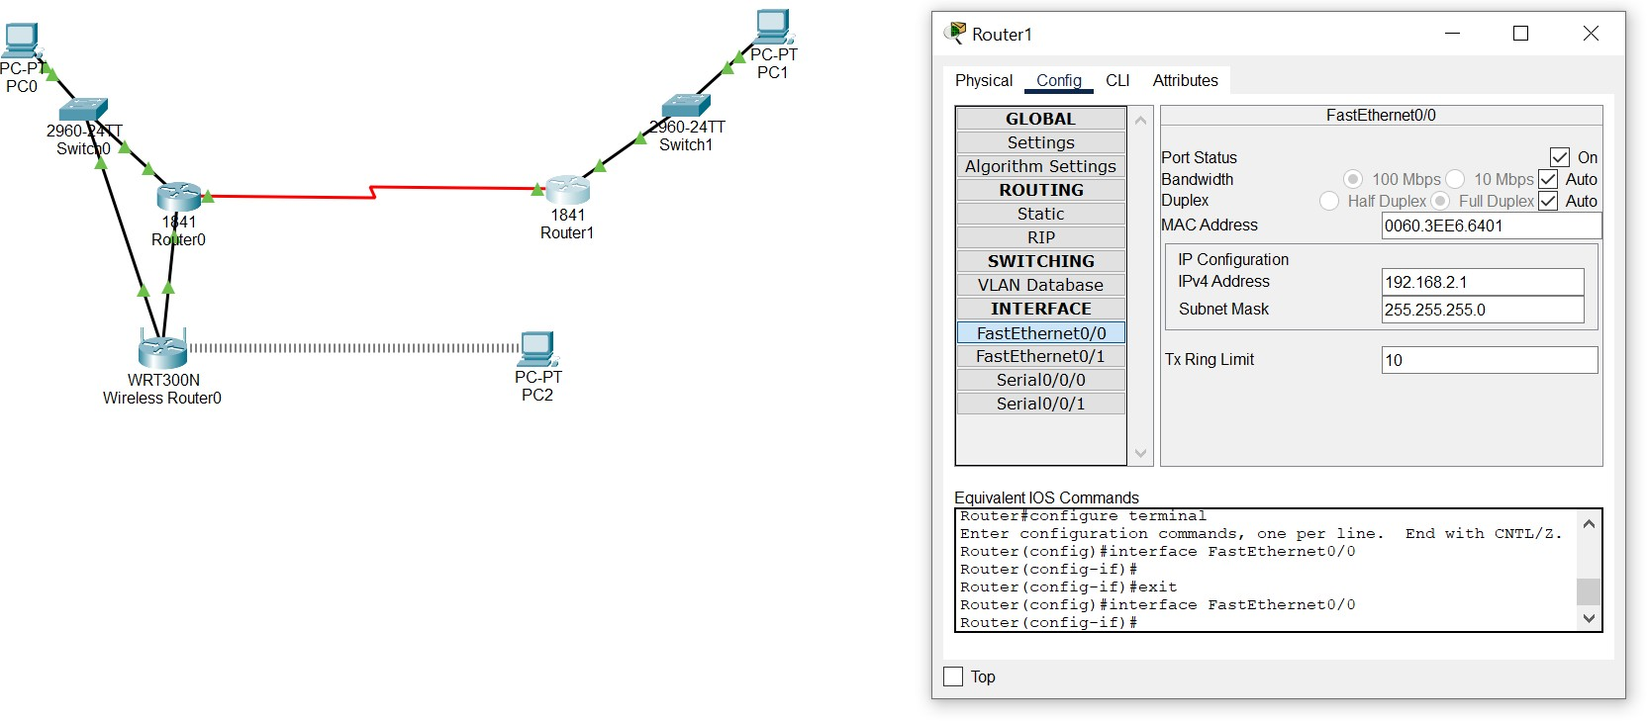

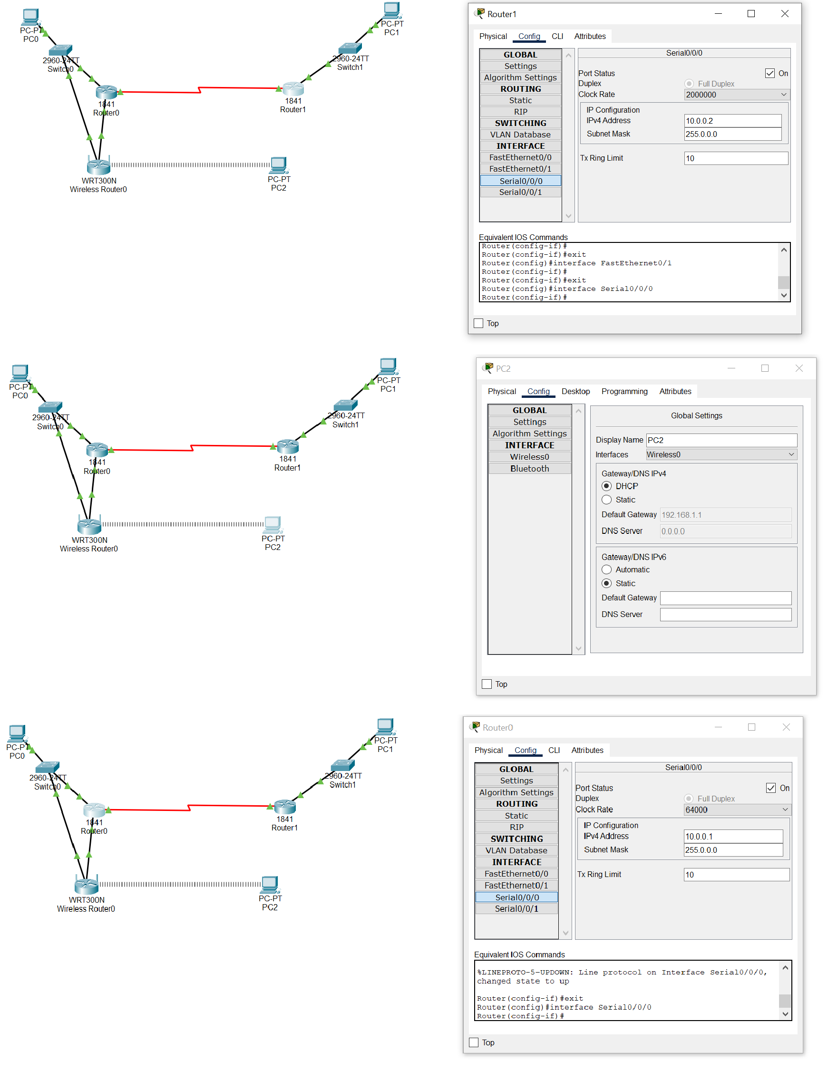

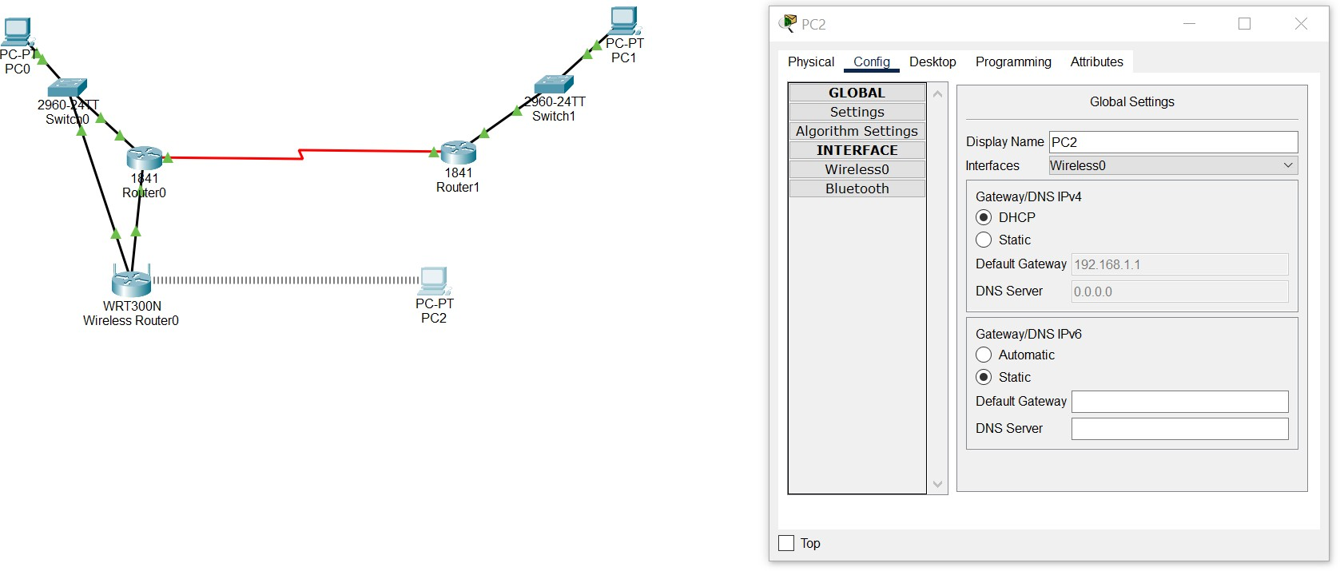

**Step 4:** Configuring wireless router

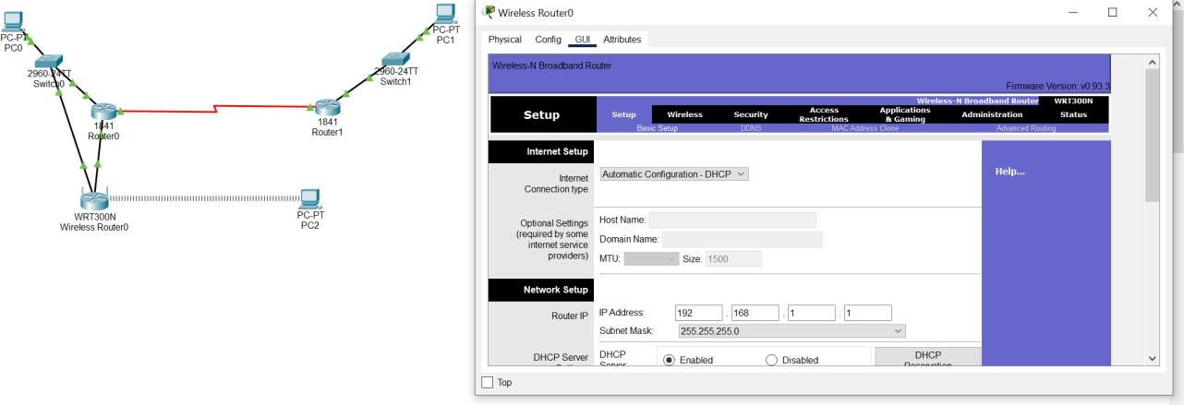

**Step 5:** Adding security mode as **WEP** and setting up key as **2a2a2a2a2a**

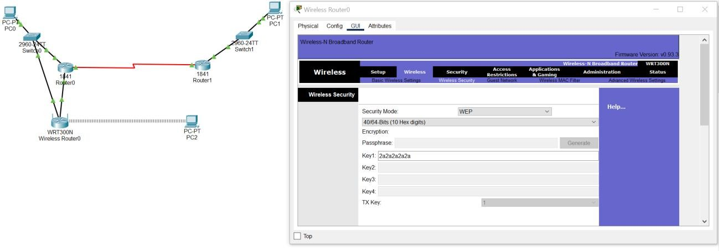

# Checking connection:

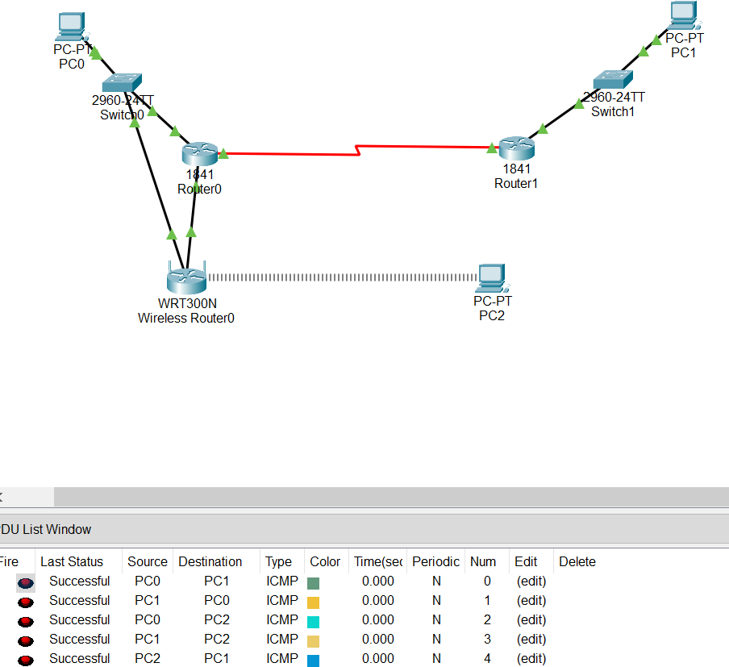

**Practical No: 02 Aim:** Demonstrating Distribution Layer Functions **Components:** Router, Switch, Device (PC)

**Theory:** The distribution layer is the smart layer in the three-layer model. Routing, filtering, and QoS policies are managed at the distribution layer. Distribution layer devices also often manage individual branch-office WAN connections. This layer is also called the Workgroup layer.

# Cisco Packet Tracer Setup:-

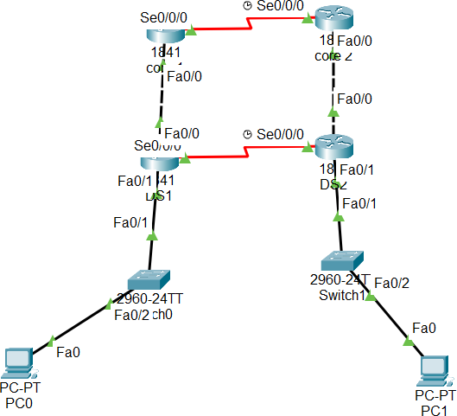

**Implementation:**

**Step 1:** Arranging devices

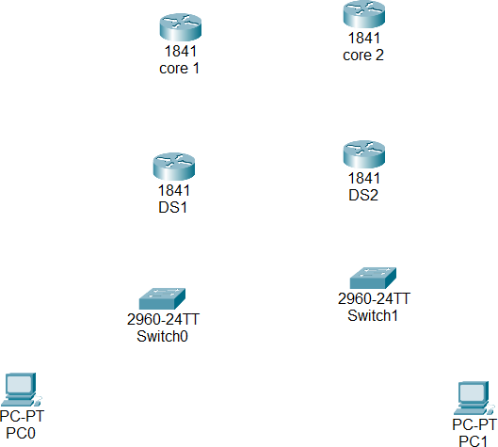

**Step 2:** Creating connections using Ethernet and serial cable between devices

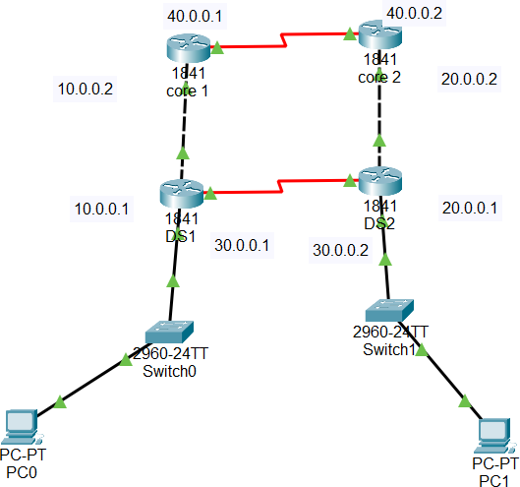

**Step 3:** Configuring all devices

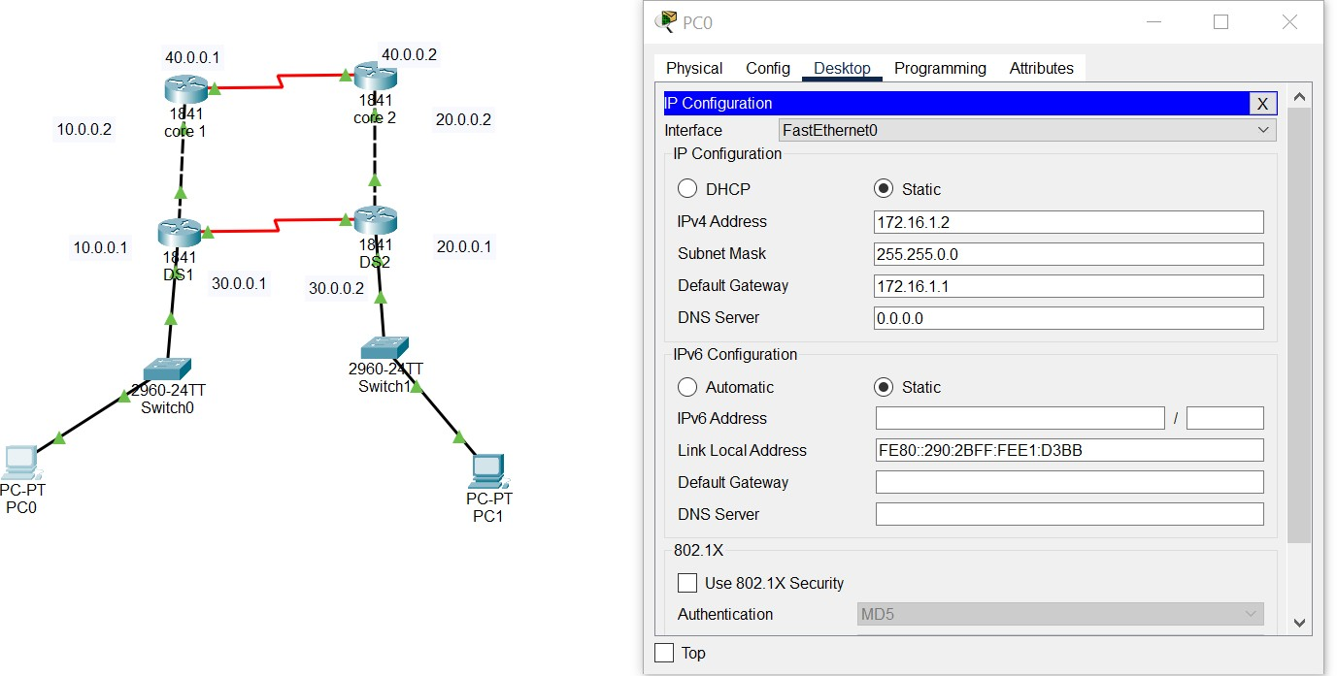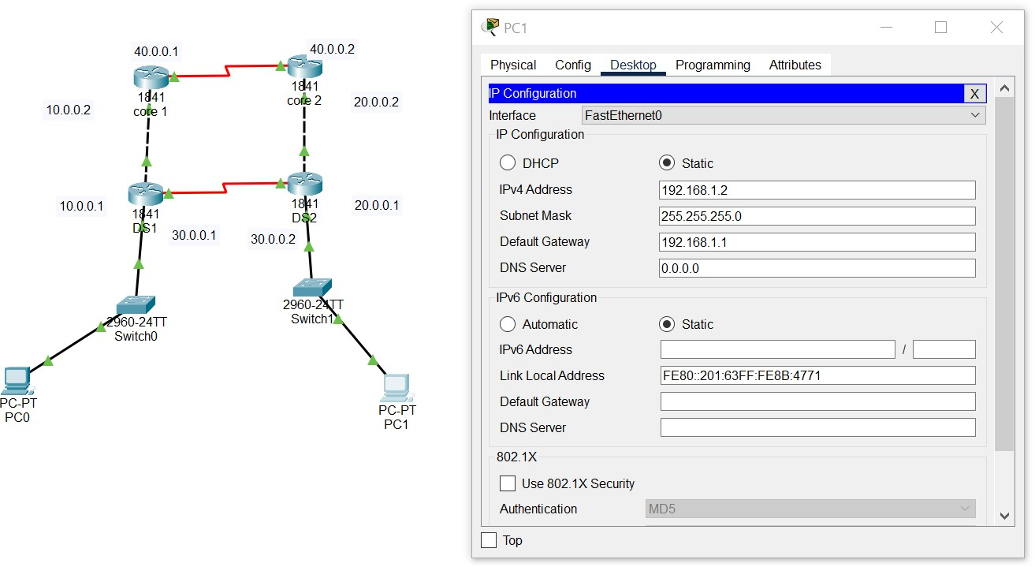

**Step 4:** Setting up distribution layer using router

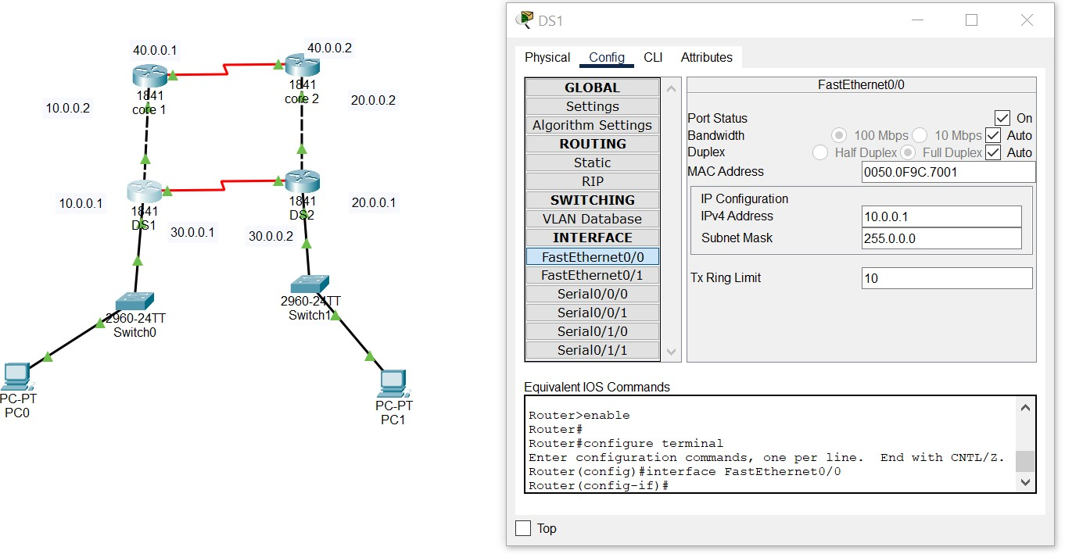

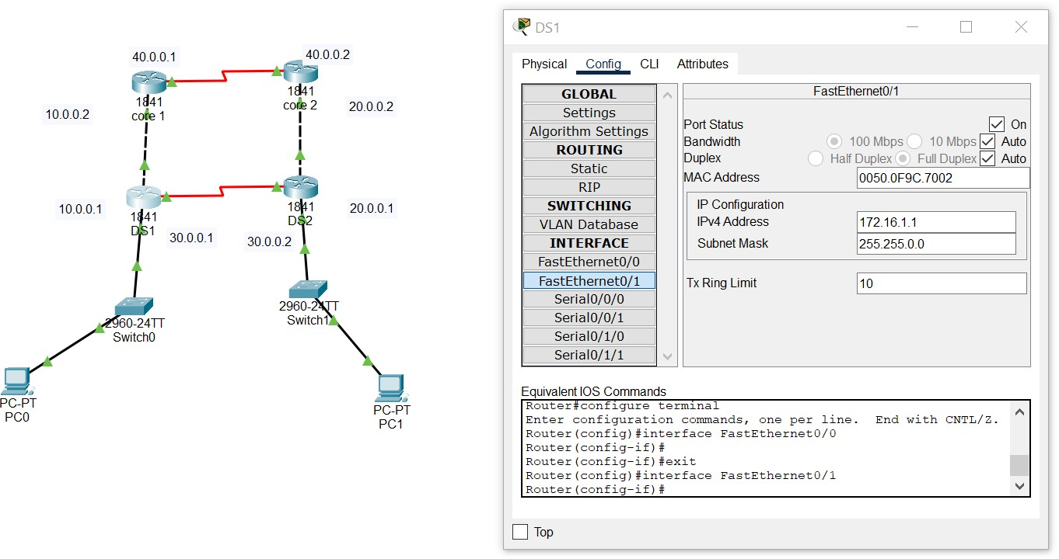

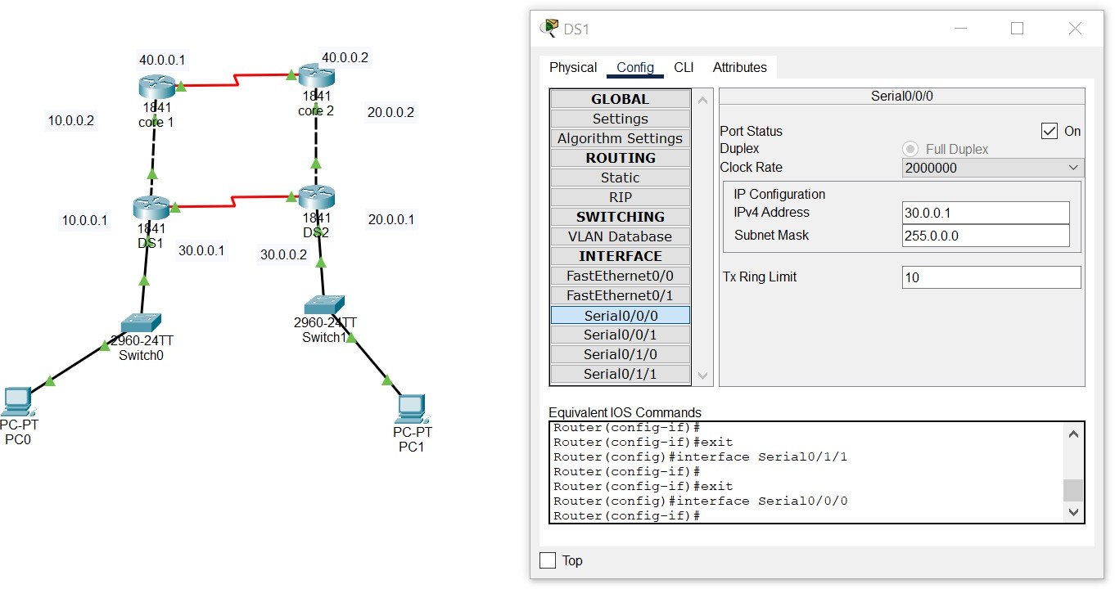

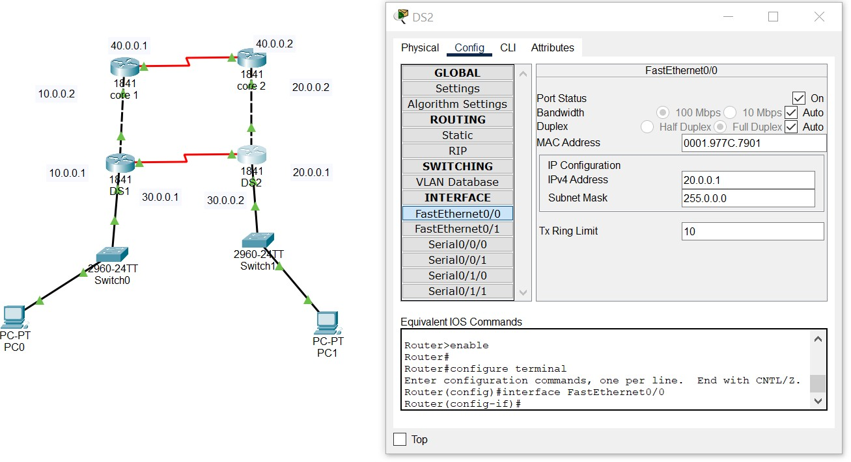

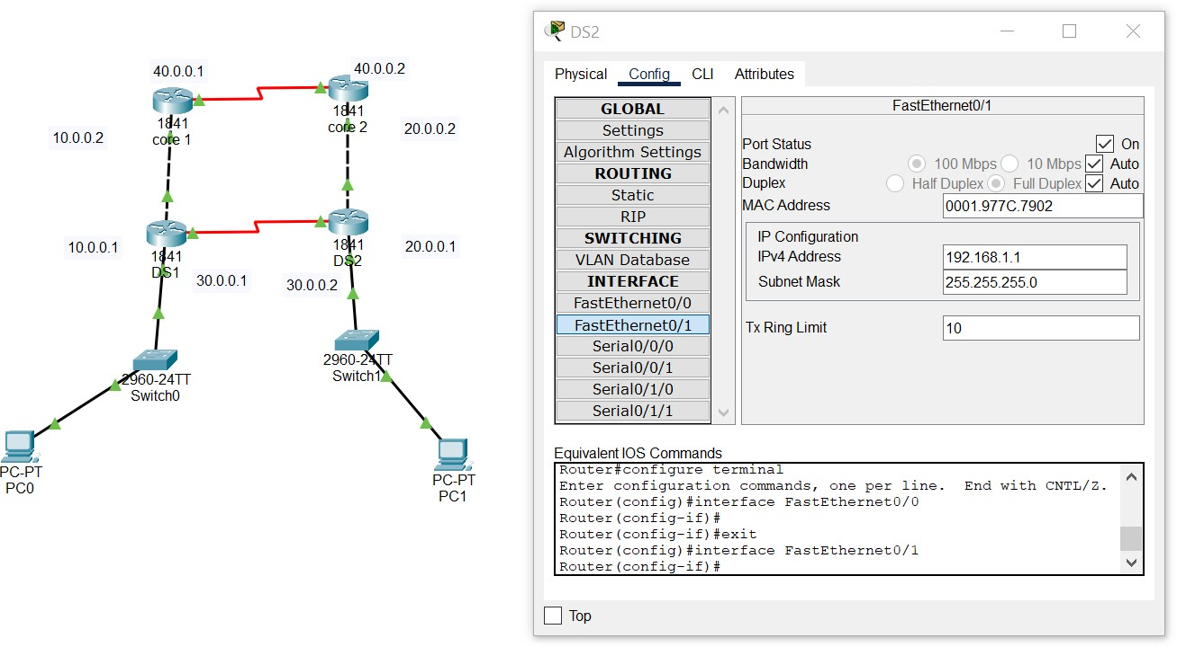

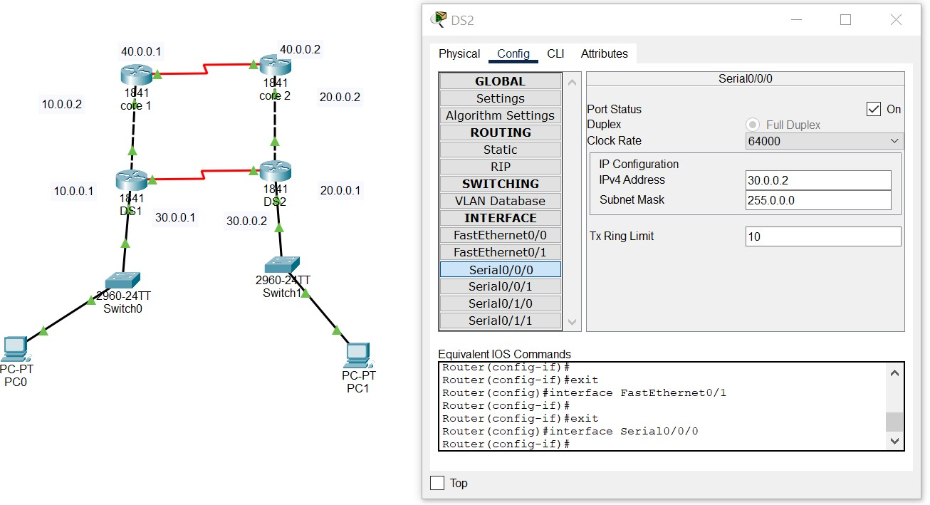

**Step 5:** Setting up core routers

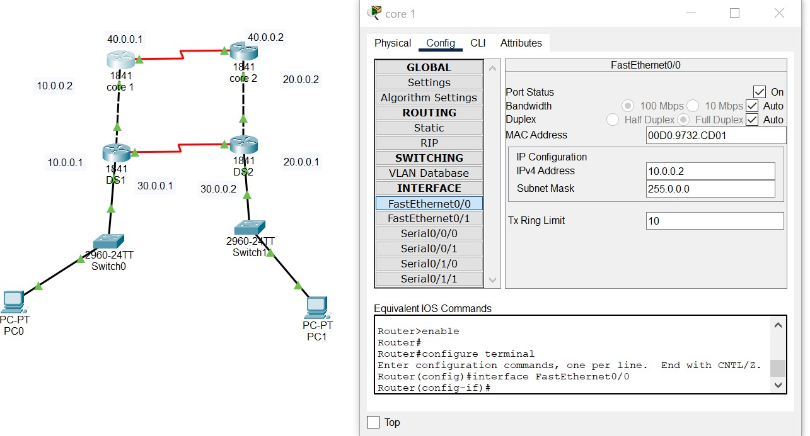

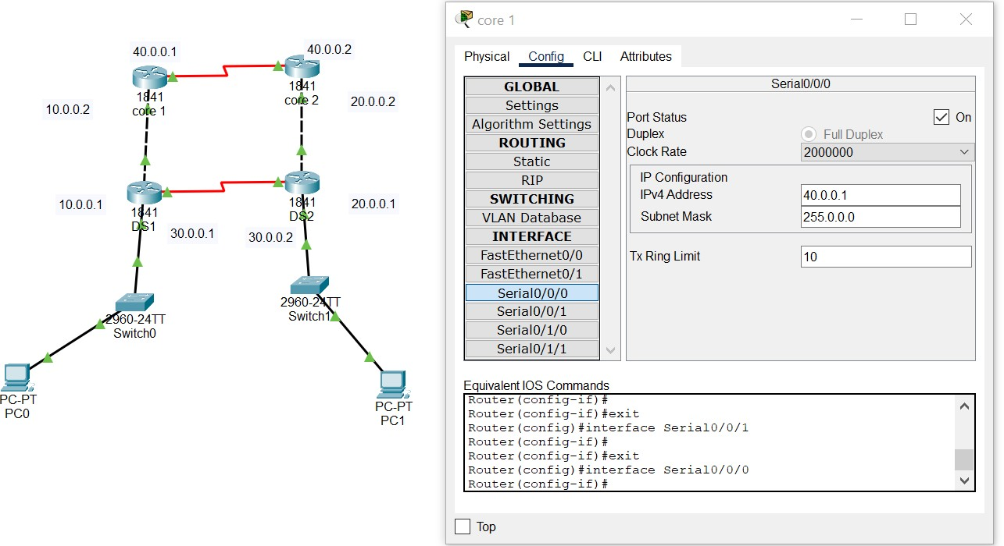

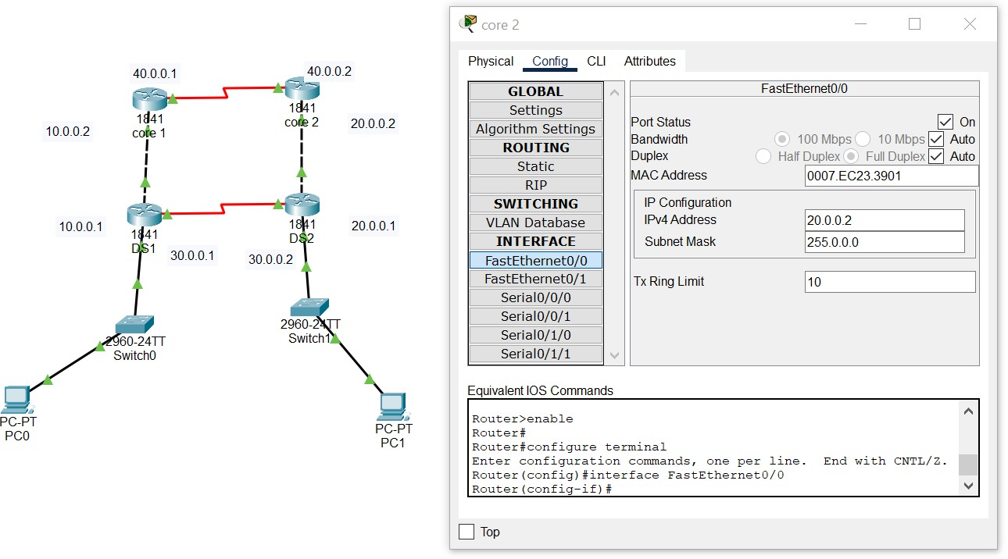

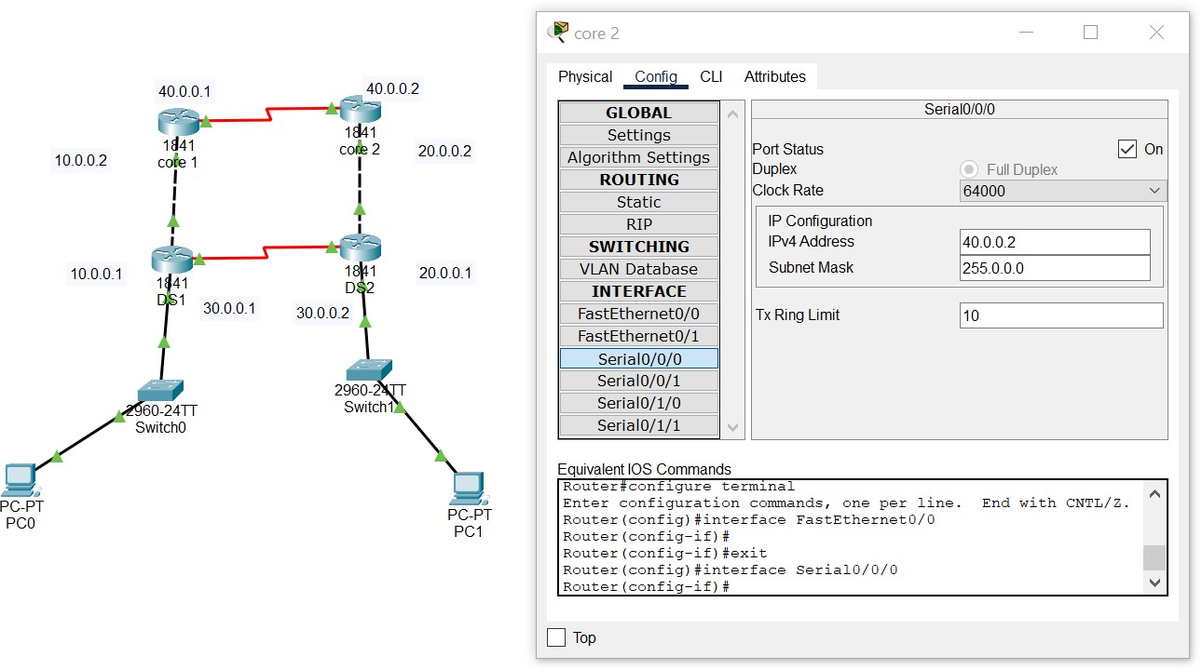

**Step 6:** Setting up RIP routing protocol

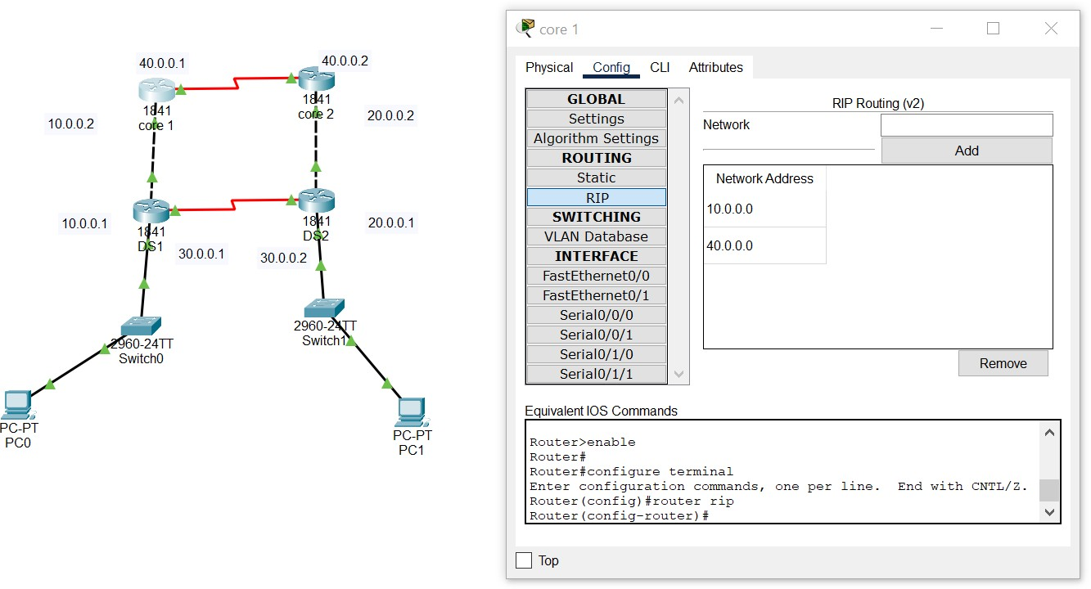

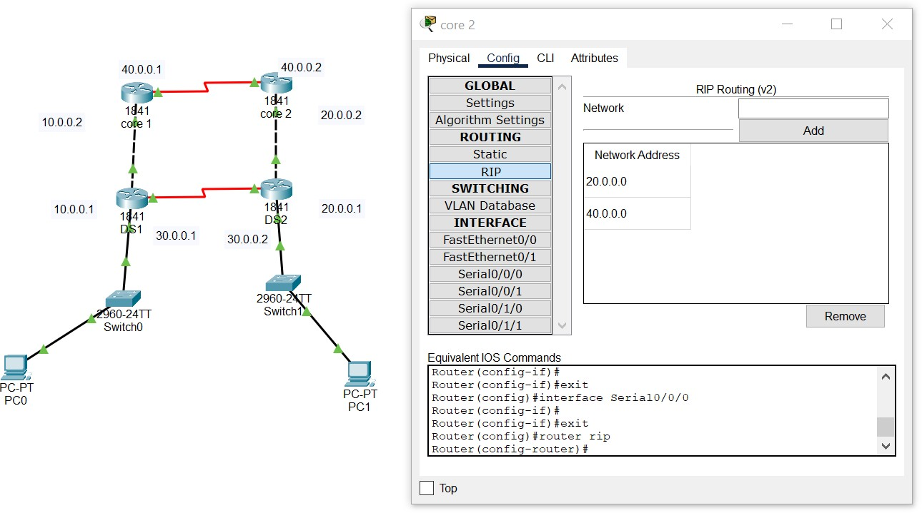

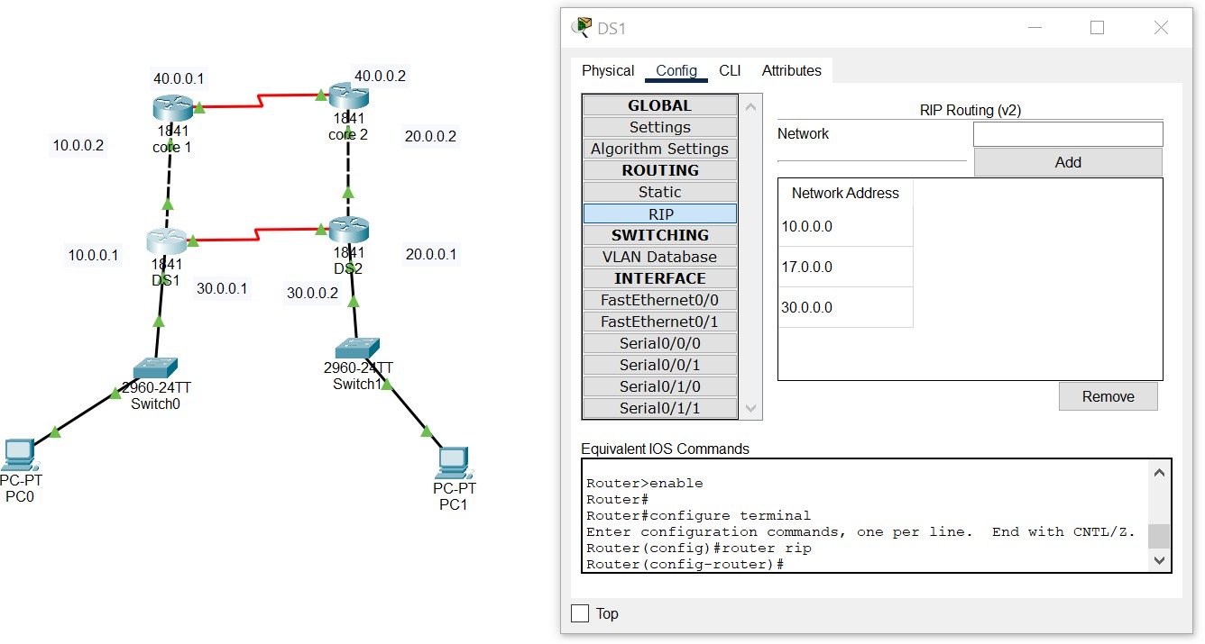

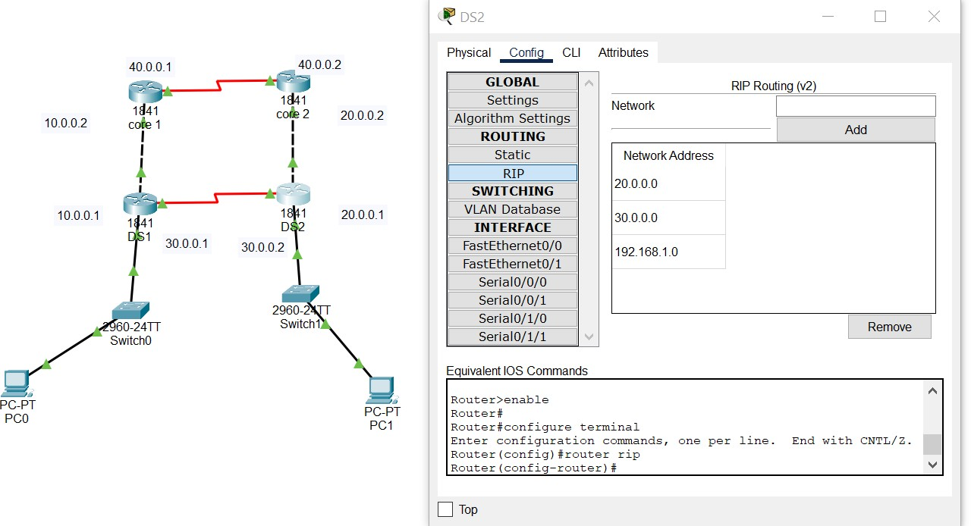

# Checking connection:

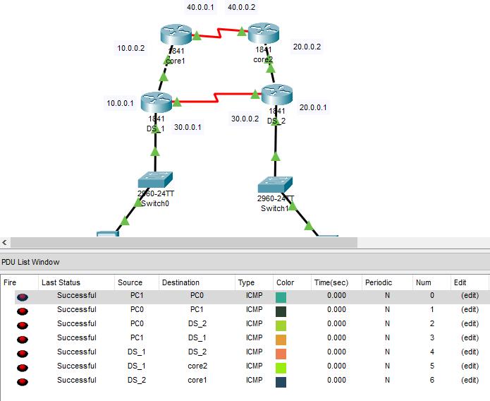

**Practical No: 05 Aim:** Configure Auto Profiles ACU Utilities

**Components:** WLC (Wireless LAN Controller), AP (Access point), Switch, Server, Laptop, Smartphone, Tablet

**Theory:** The Use Auto Profile Selection option causes the driver for the client adapter to automatically select a profile from the list of profiles that were set up to be included in auto profile selection. The name of the profile that is being used appears in the box to the right of the Use Auto Profile Selection option. If the client adapter loses association for more than 10 seconds, the driver switches automatically to another profile that is included in Auto Profile Selection. The adapter will not switch profiles as long as it remains associated or reassociates within 10 seconds (or within the time specified by the LEAP authentication timeout value). To force the client adapter to associate to a different AP (AP), Auto Profile Selection must be disabled and a new profile must be selected.

# Cisco Packet Tracer Setup:-

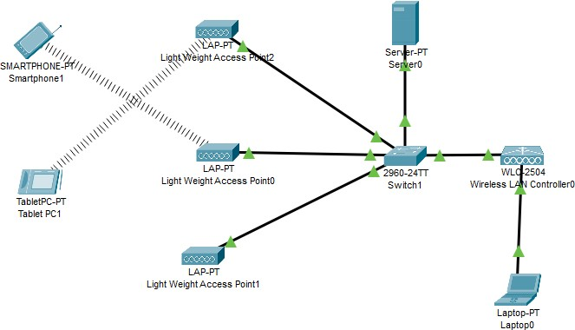

**Implementation:**

**Step 1:** Arranging devices and creating connections

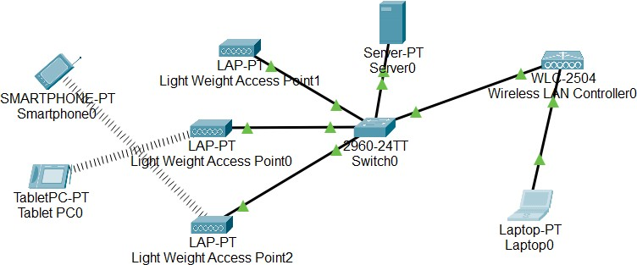

**Step 2:** WLC (Wireless LAN Controller)

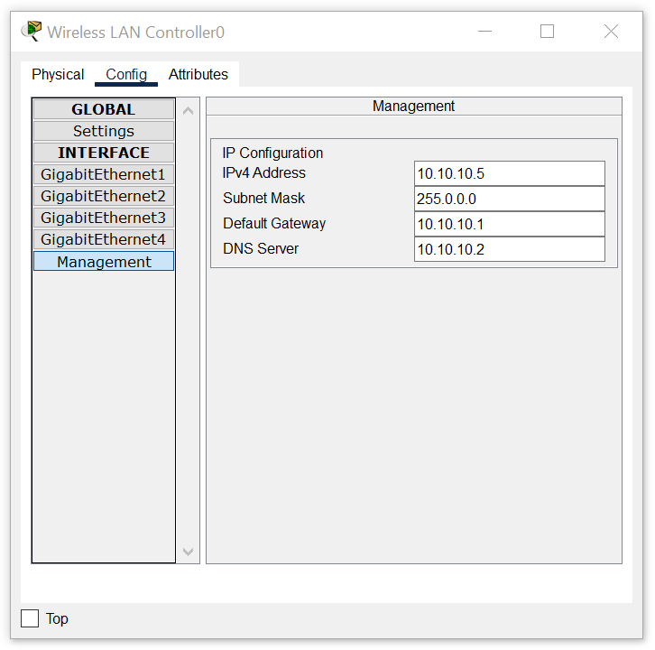

**Step 3:** Configuring Laptop and server and checking connection

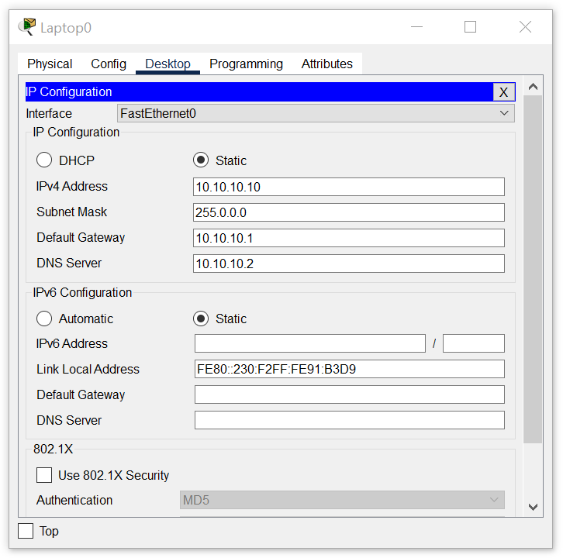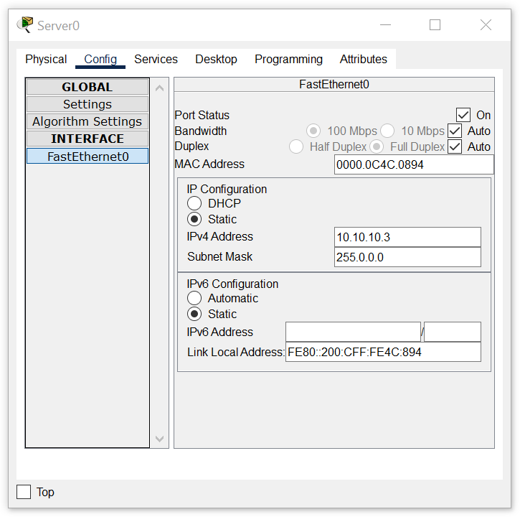

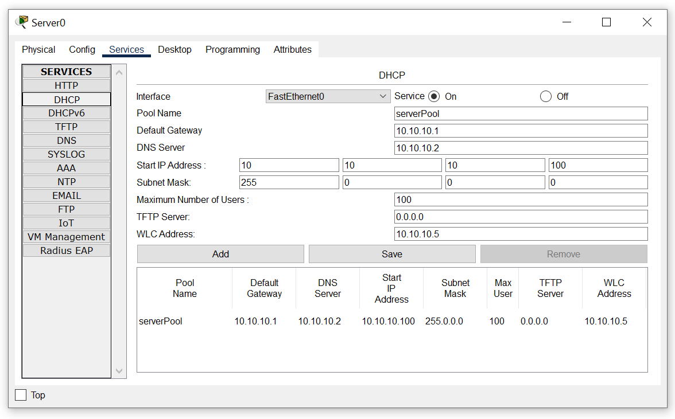

Check the connection

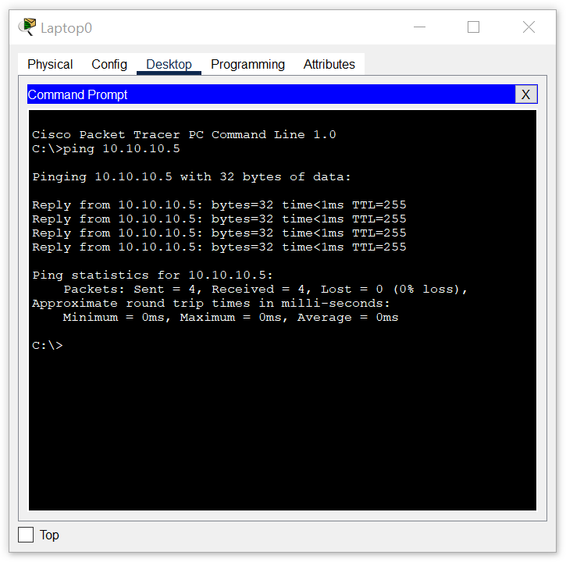

**Step 4:** Configuring Admin settings using address ([http://10.10.10.5](http://10.10.10.5/))

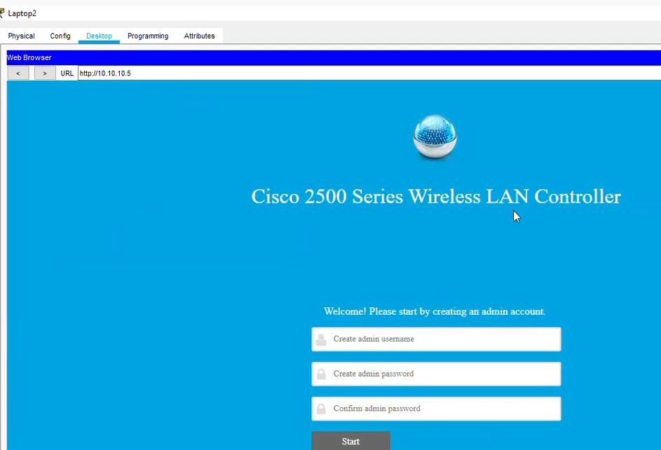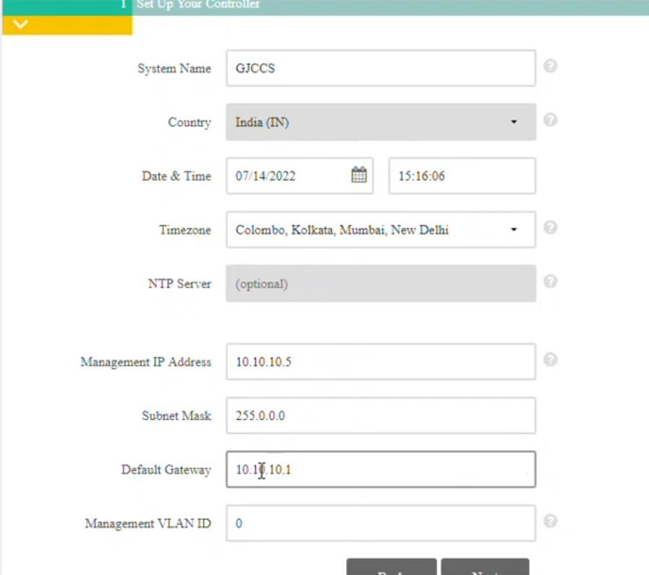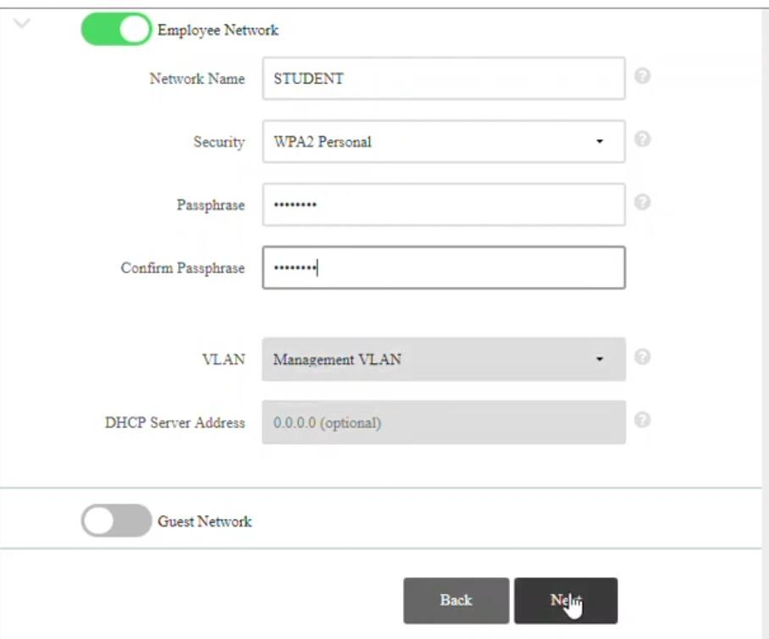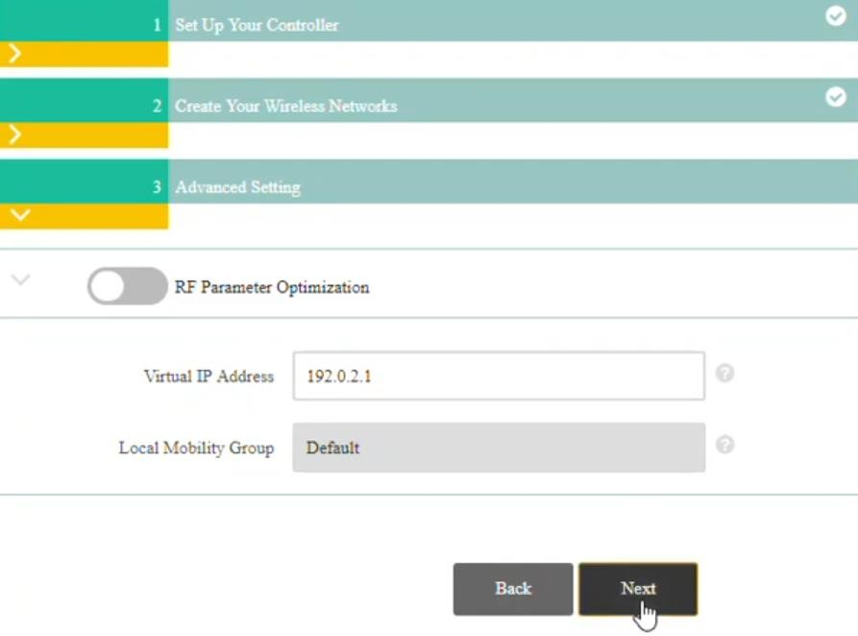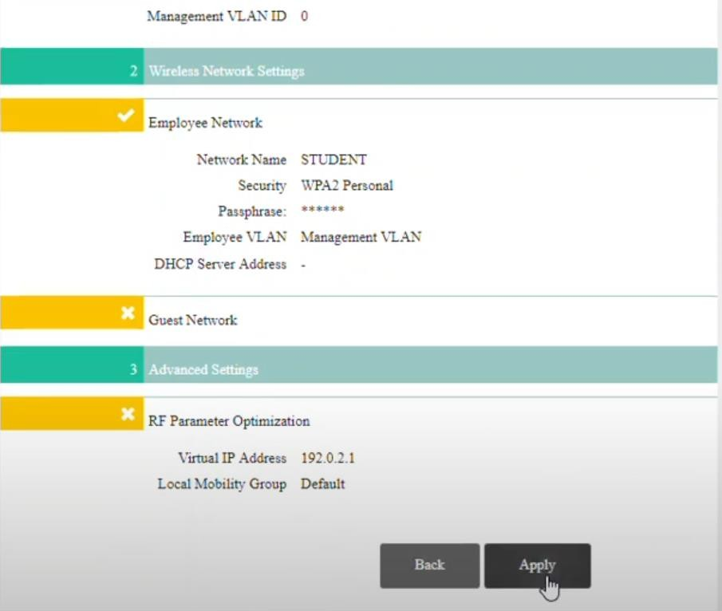

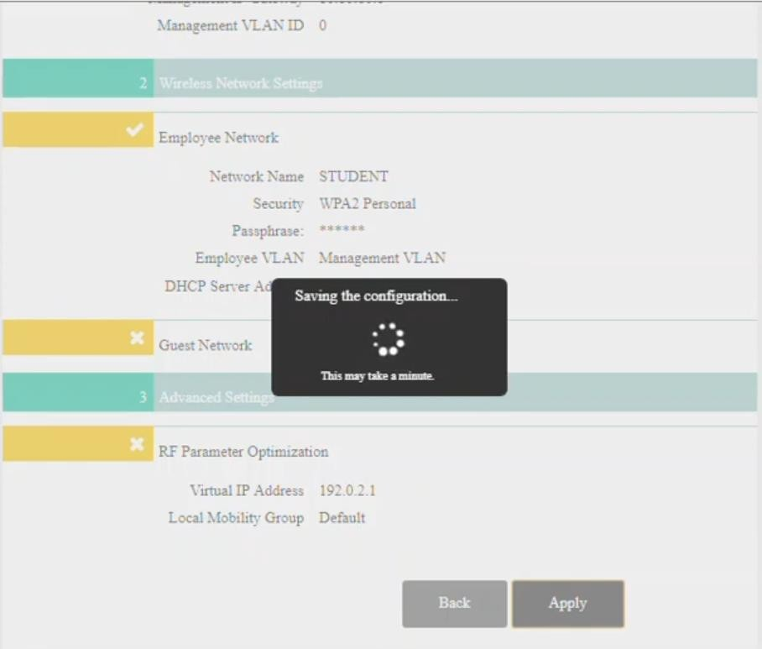

**Step 5:** Login back to Admin Panel using address ([https://10.10.10.5](https://10.10.10.5/))

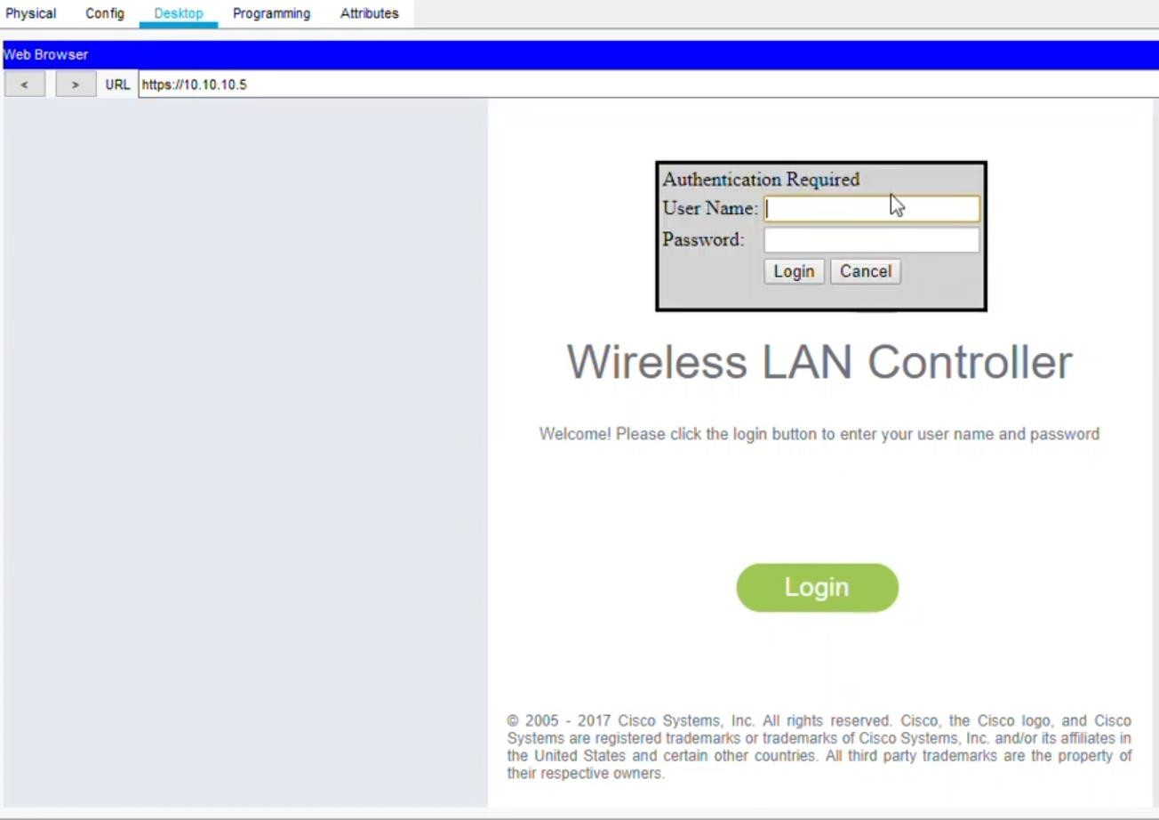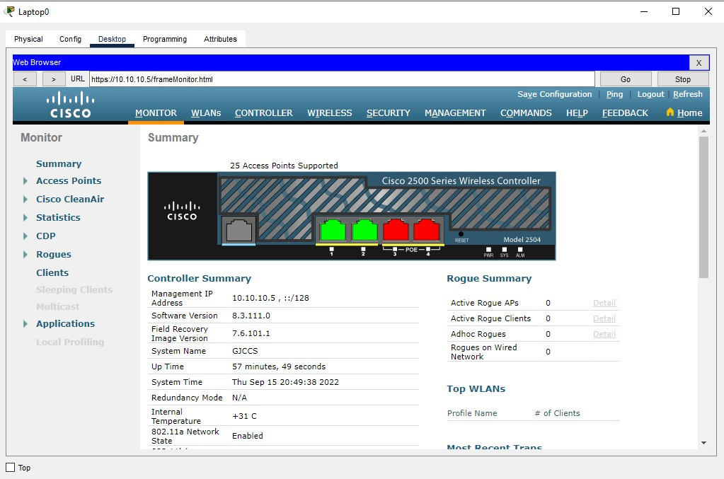

Check the Access points AP’s

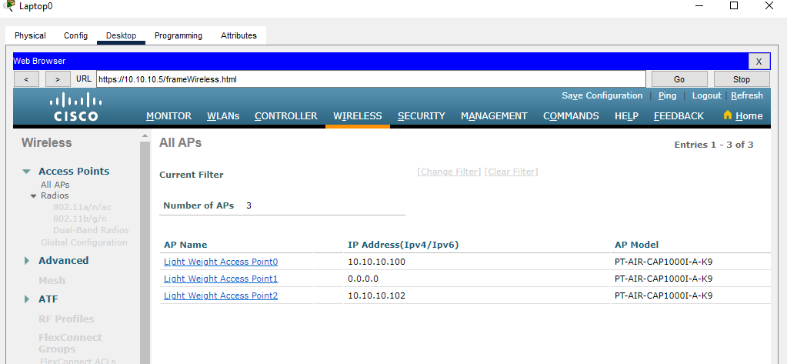

Go to WLAN’s make SSID for STUDENT to Student

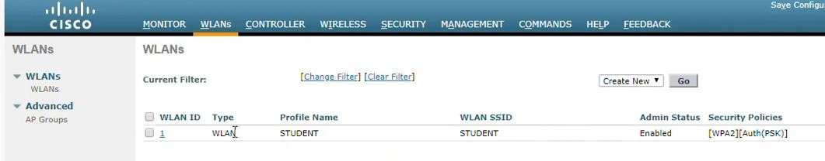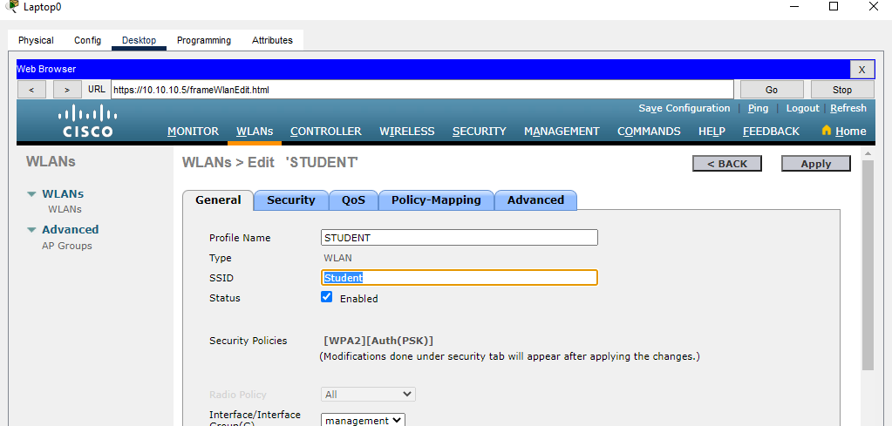

**Step 6:** Add new wireless LAN as TEACHER with SSID Teacher

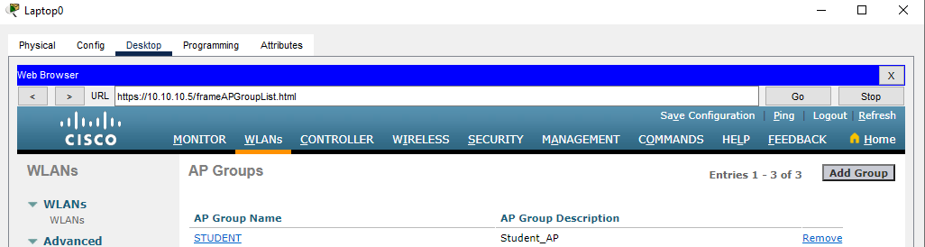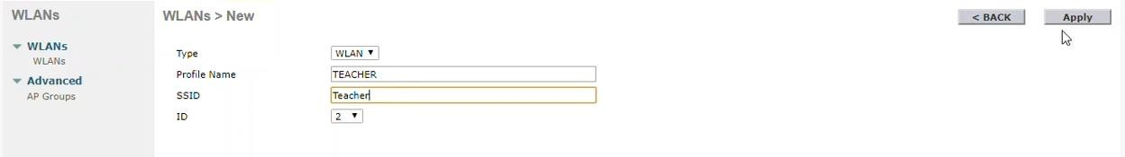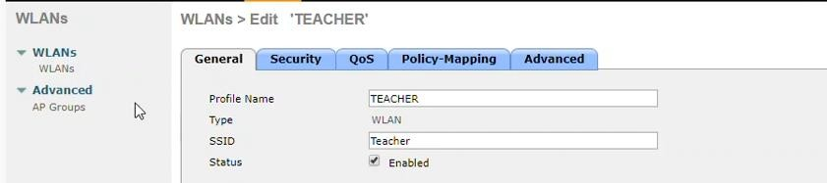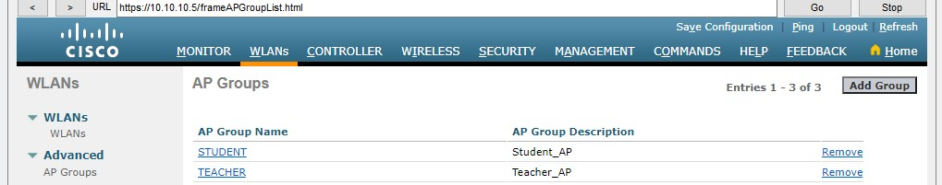

**Step 7:** Create AP Groups for TEACHER and STUDENT

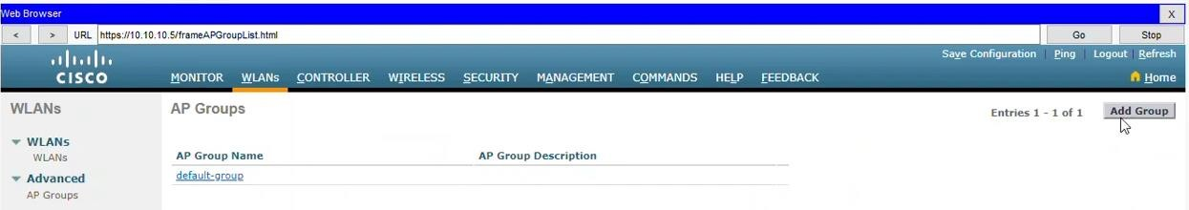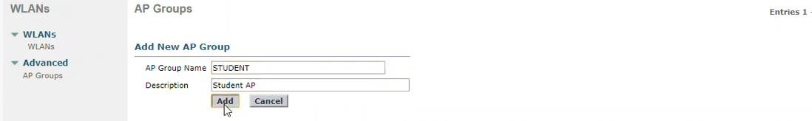

Assign wireless LAN to AP

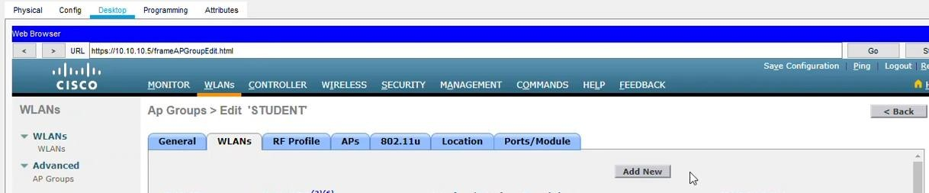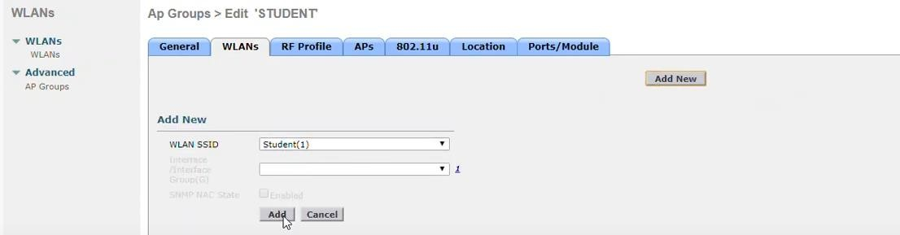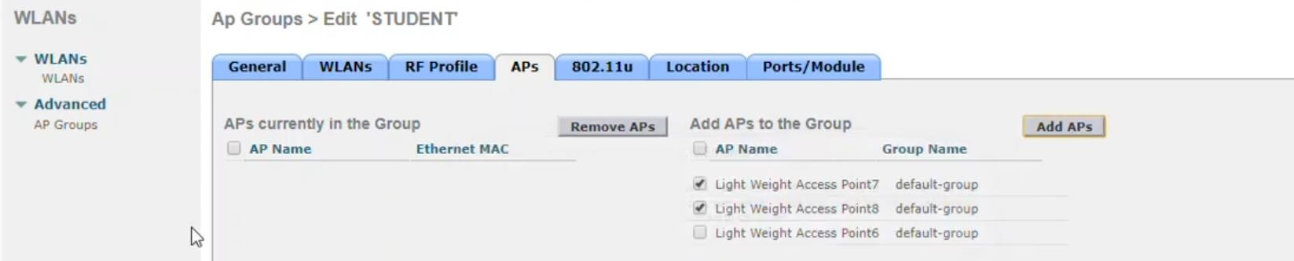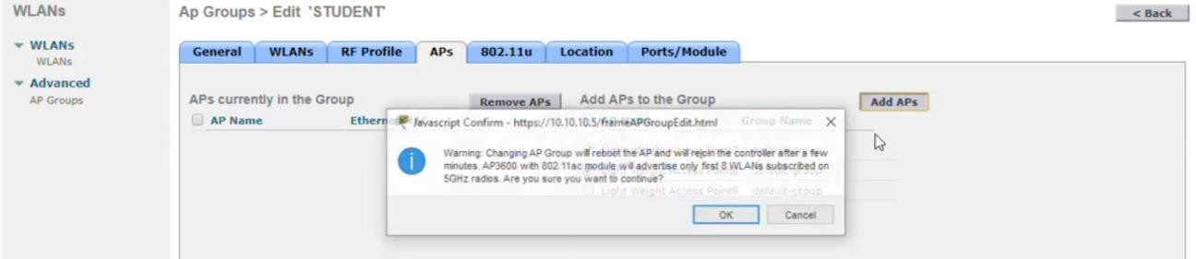

Add AP Group TEACHER

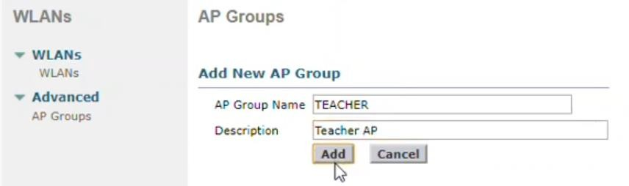

Assign wireless LAN

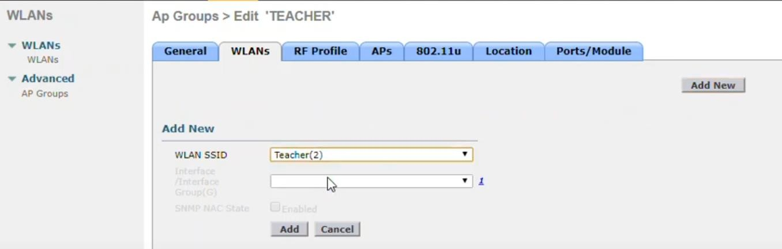

Assign AP

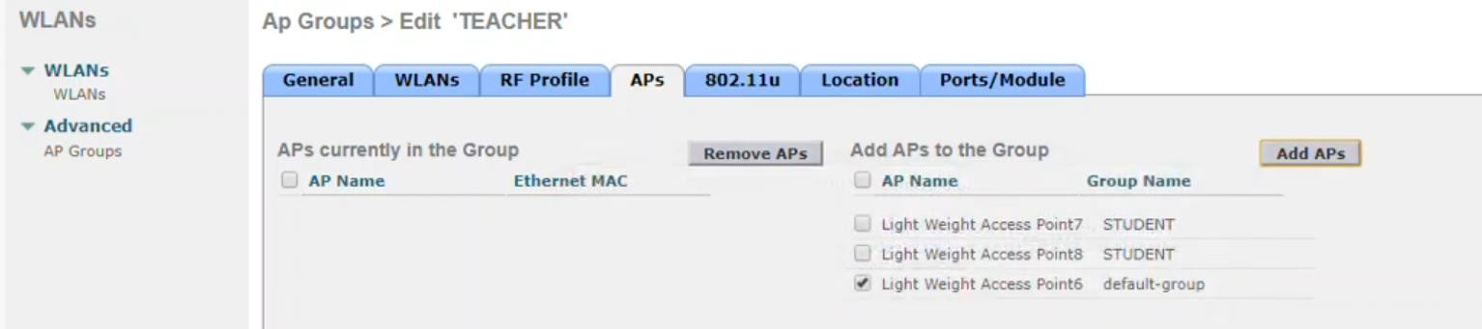

Logout from admin panel

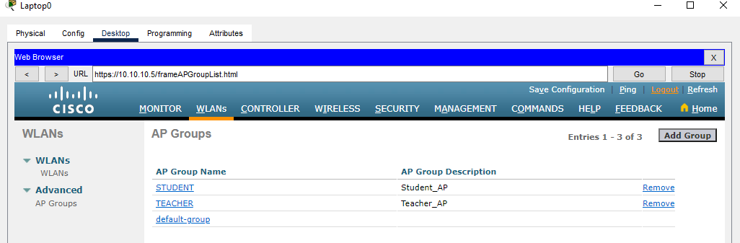

Check the assigned AP’s

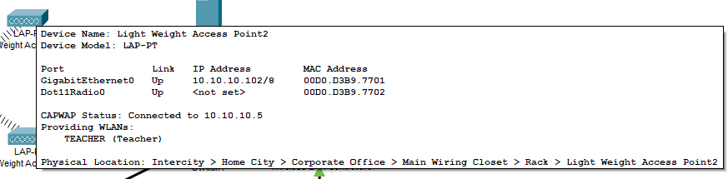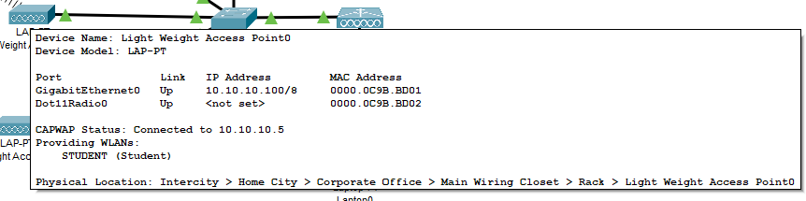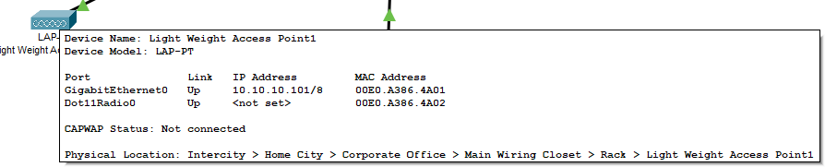

**Step 8:** Take Smartphone to connect Student AP group with wireless connection using SSID

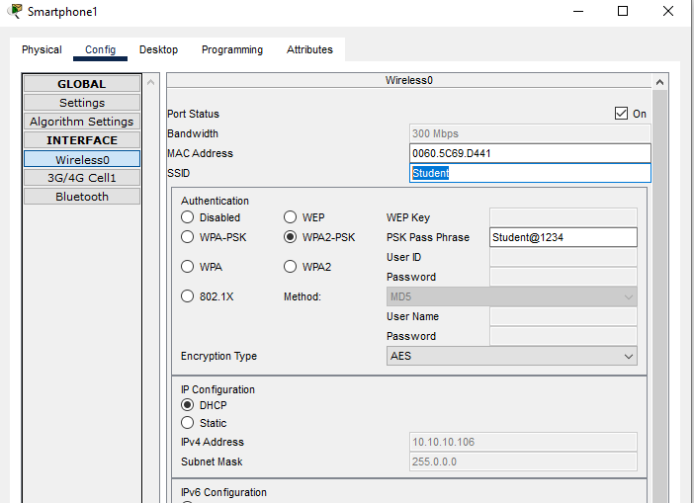

**Step 8:** Take Tablet to connect Teachers AP group with wireless connection using SSID

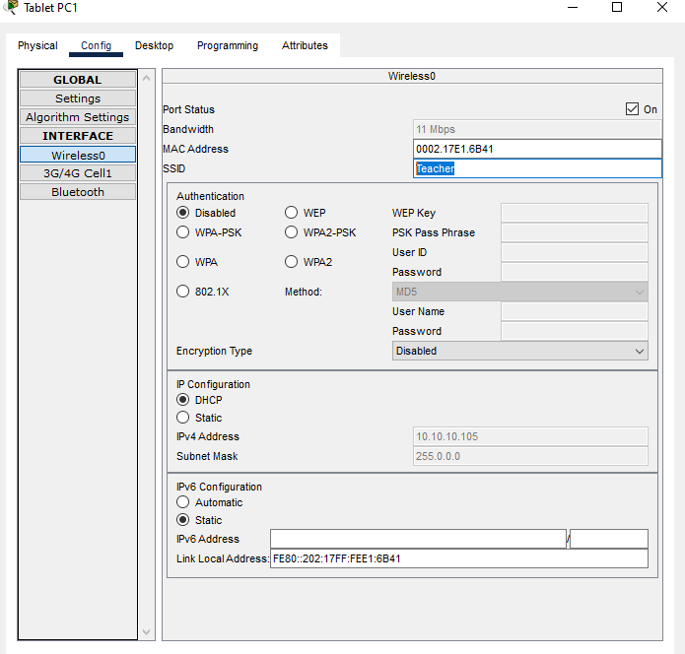

Wait for some time (min 30sec to 1min) after that re-plug the adapters of all Access points

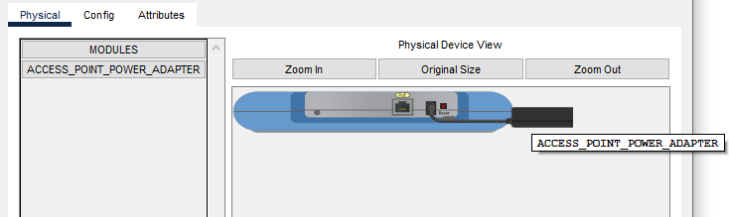

# Final Output/Connection:

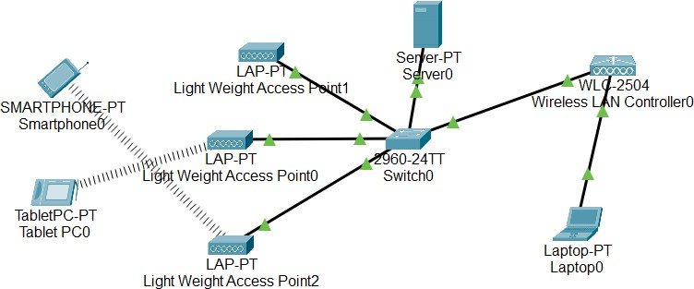

**Practical No: 04 Aim:** Planning Network-based Firewalls

**Components:** Wireless Router, Server, PC

**Theory:** Network firewalls are security devices used to stop or mitigate unauthorized access to private networks connected to the Internet, especially intranets. The only traffic allowed on the network is defined via firewall policies – any other traffic attempting to access the network is blocked.

# Cisco Packet Tracer Setup:-

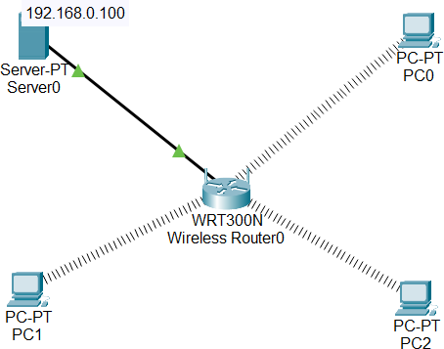

**Implementation:**

**Step 1:** Arranging devices and creating connections



**Step 2:** Configure wireless router and connect server to wireless router using Ethernet cable

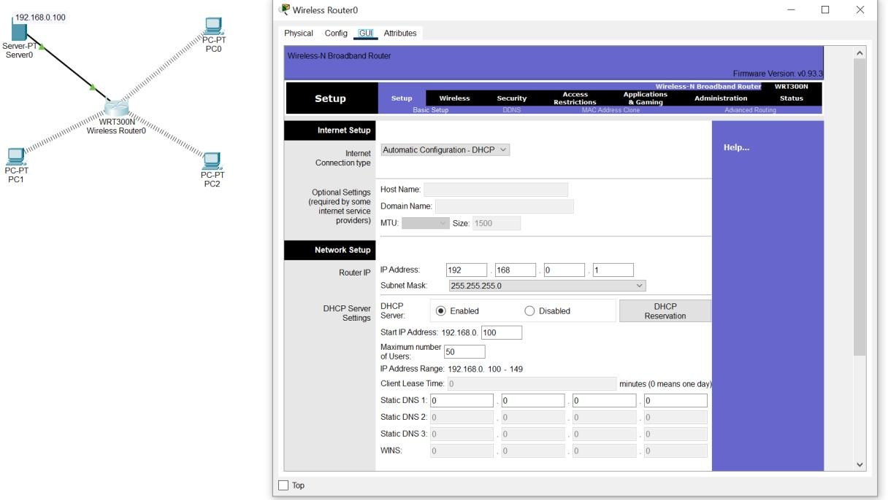

**Step 3:** Configure Server

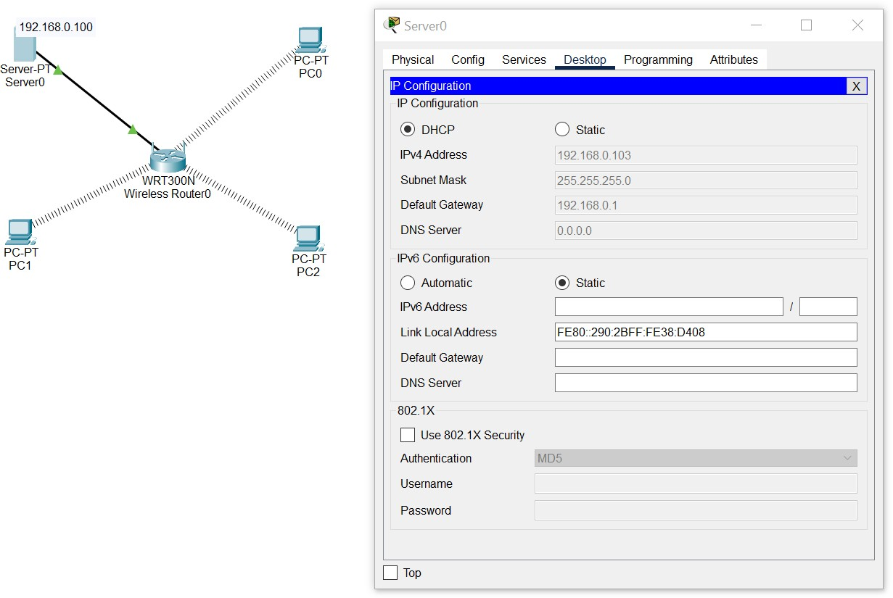

**Step 4:** Configure and connect all PC’s to wireless router Changing port to wireless adapter of all PC’s

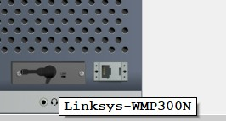

After adding wireless adapter of all PC’s they will automatically get connected with wireless outer because of DHCP



**Step 5:** Checking connection of pc’s with server

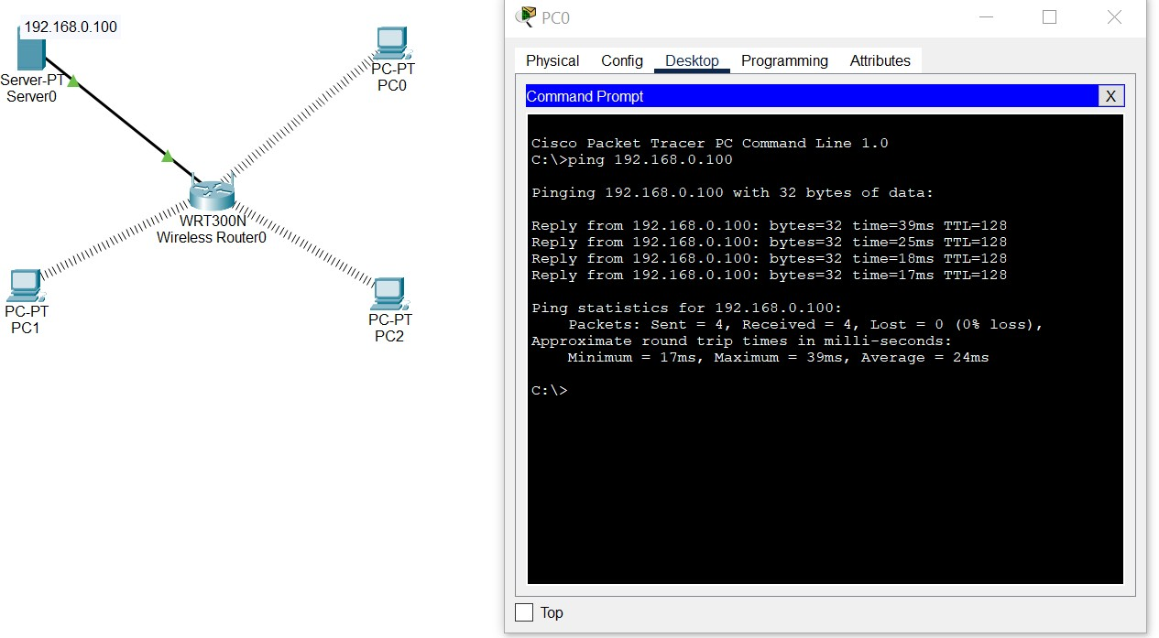

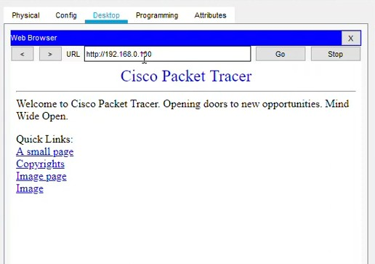

If receiving response from server our connection is done successfully

**Step 6:** Configure IPv4 firewall to setup networks based firewall

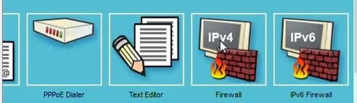

Add conditions

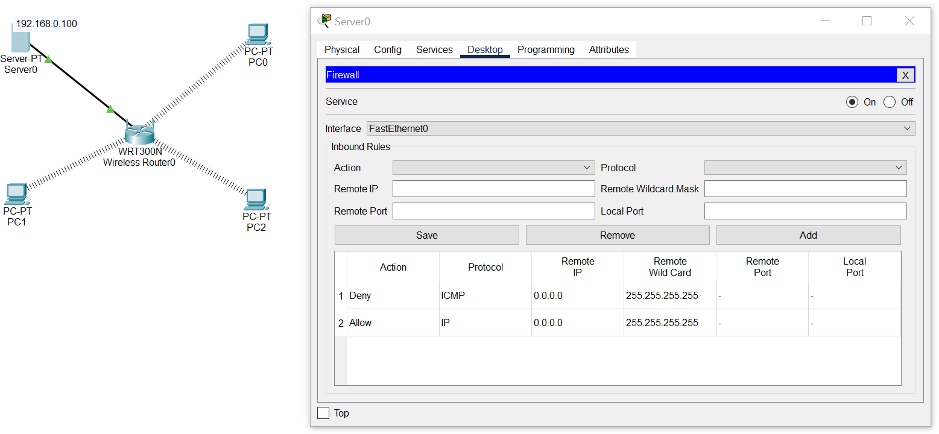

After the configuration is done for firewall we are unable to ping to server

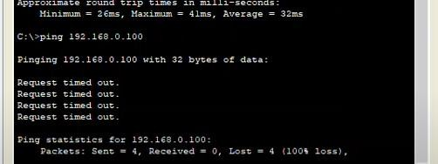

But we can access the server data (view)

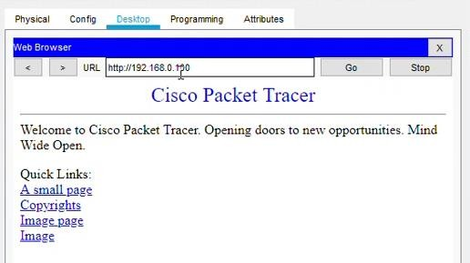

# Practical No: 06

**Aim:** Creating an Adhoc Network

**Components:** Wireless Router, PC

**Theory:** Ad hoc networks are mostly wireless local area networks (LANs). The devices communicate with each other directly instead of relying on a base station or access points as in wireless LANs for data transfer co-ordination. Each device participates in routing activity, by determining the route using the routing algorithm and forwarding data to other devices via this route.

# Cisco Packet Tracer Setup:-

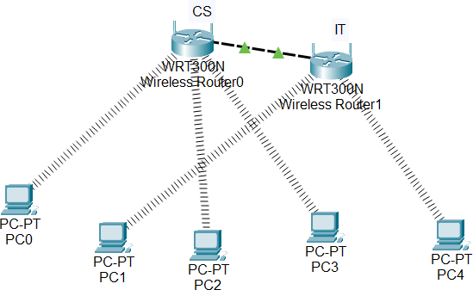

**Implementation:-**

**Step1:** Arrange all components i.e. Wireless Router and PC’s



**Step2:** Configure wireless routers and connect both of them to each other using Ethernet ports

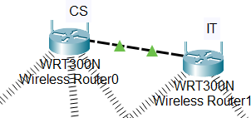

Router 1:

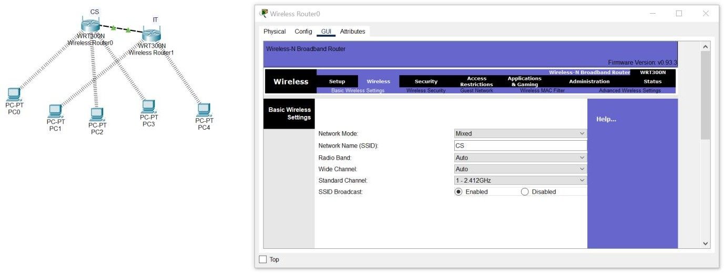

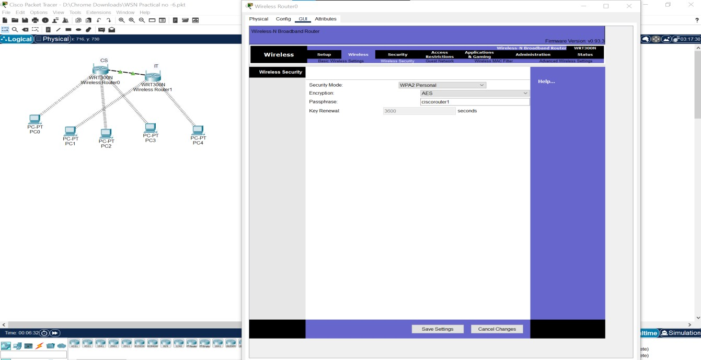

Router 2:

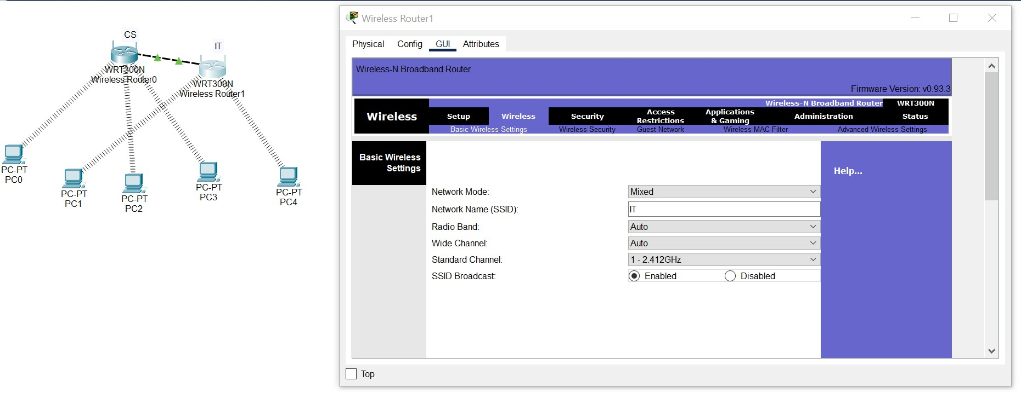

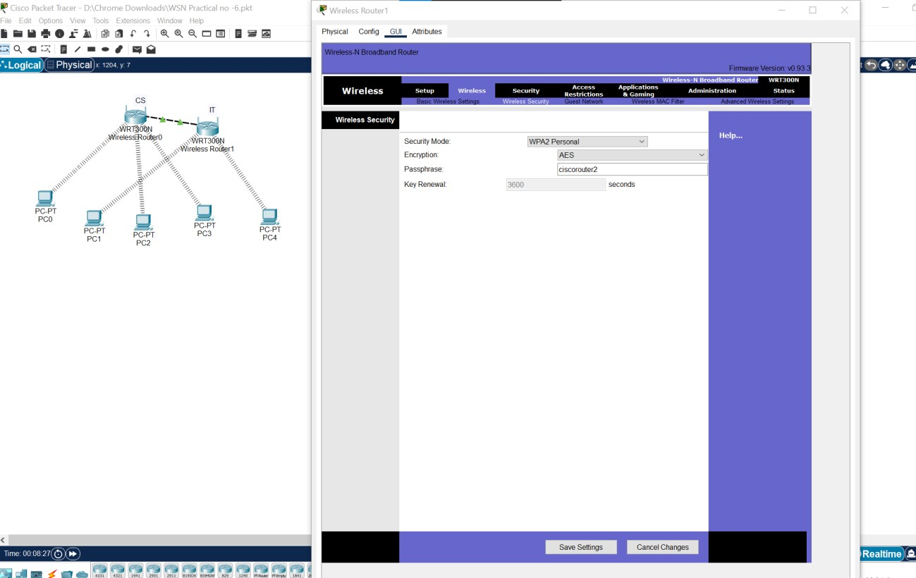

**Step3:** Connect all machines/devices (PC’s) to respective router as per our requirements.

Change the Port of all pc’s with wireless adapter

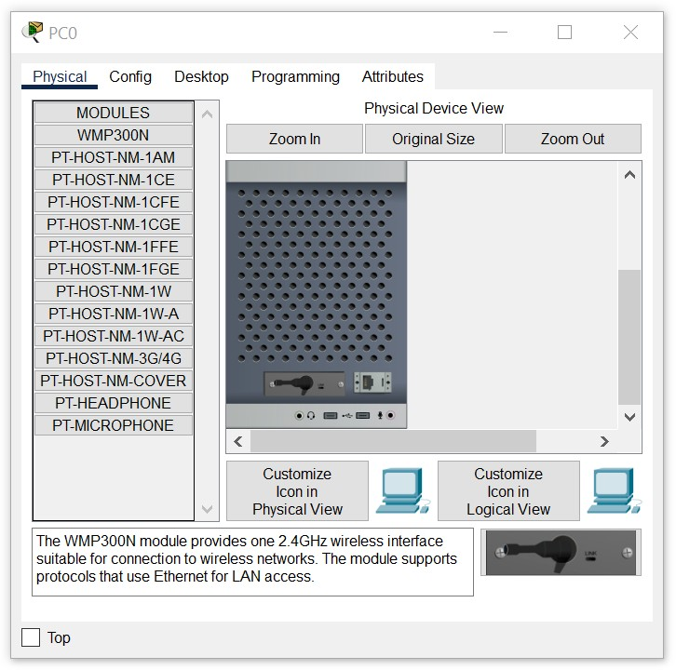

Configure Wireless connection

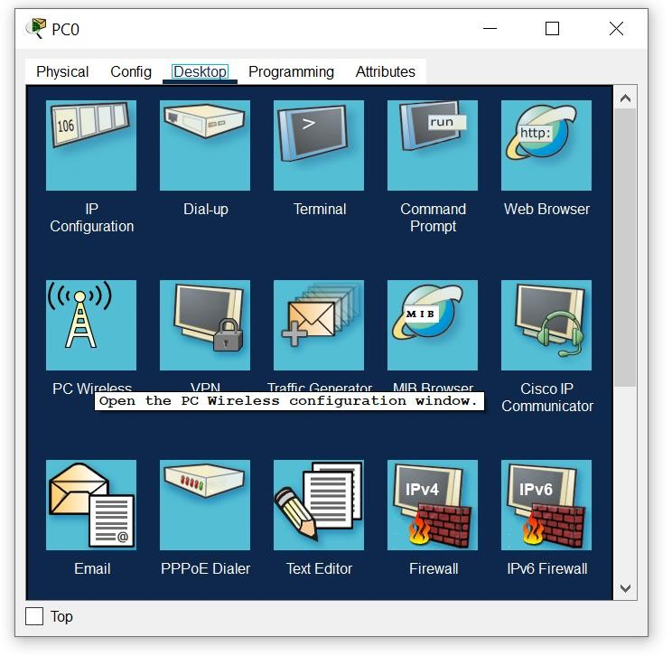

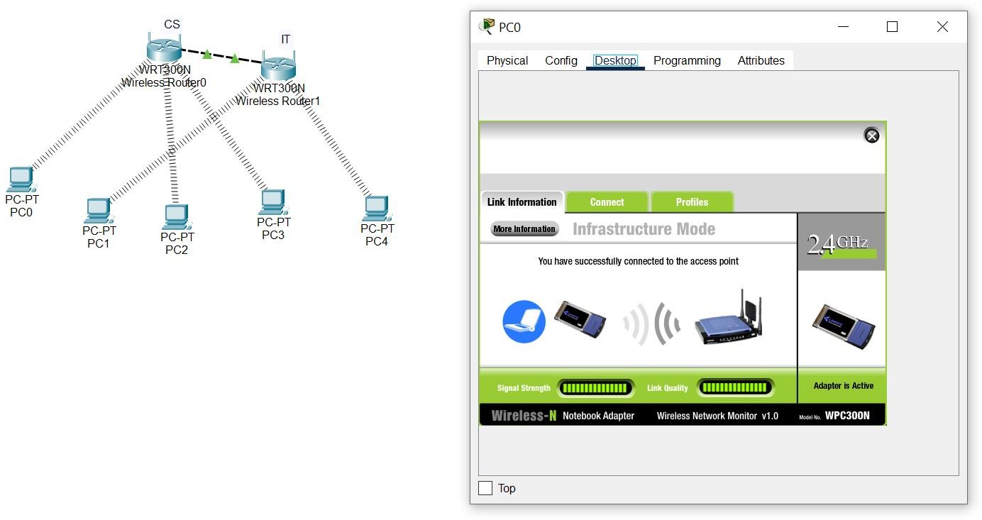

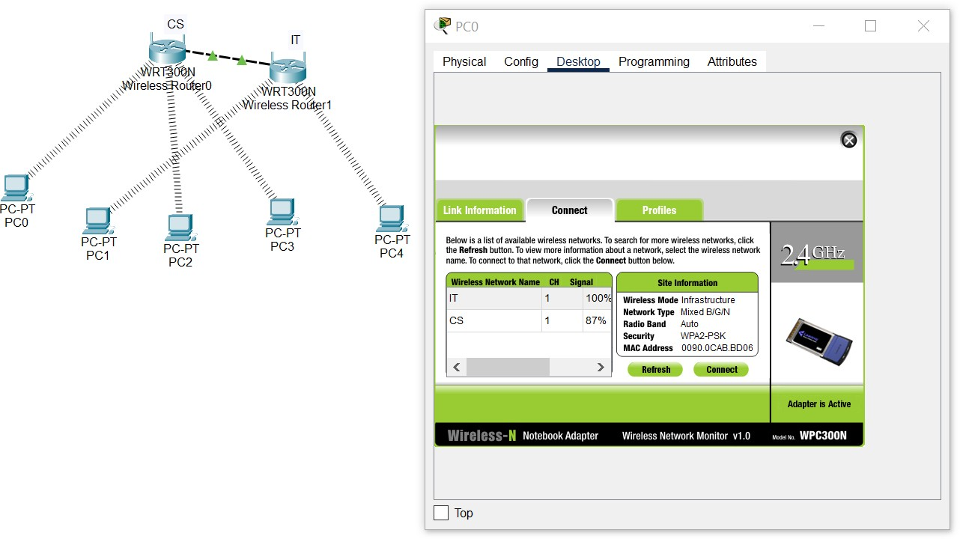

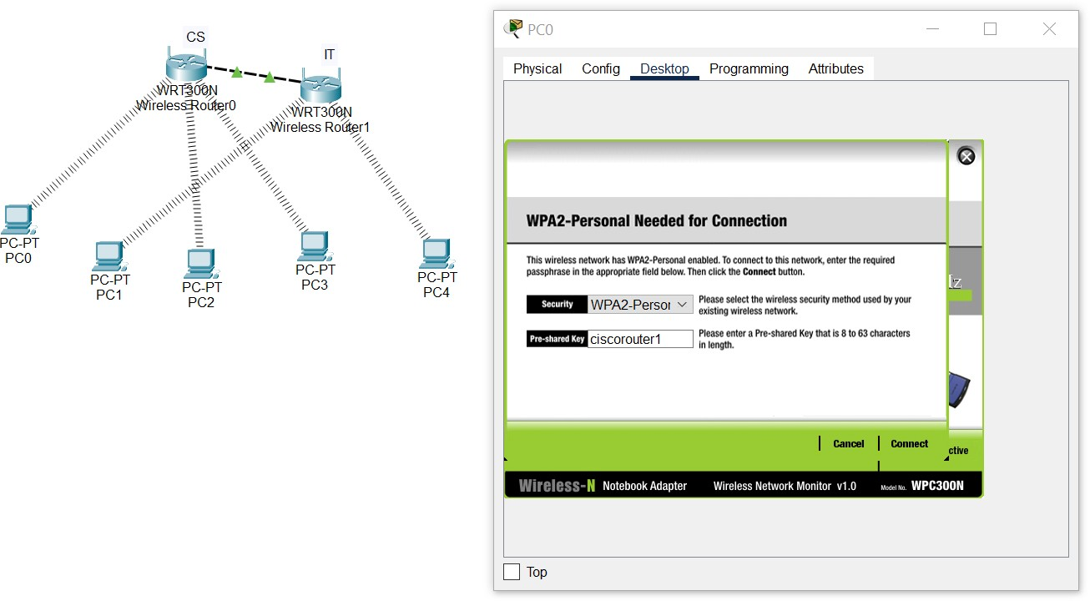

Do similar configuration to all respective PC’s

**Step4:** Check the Connection

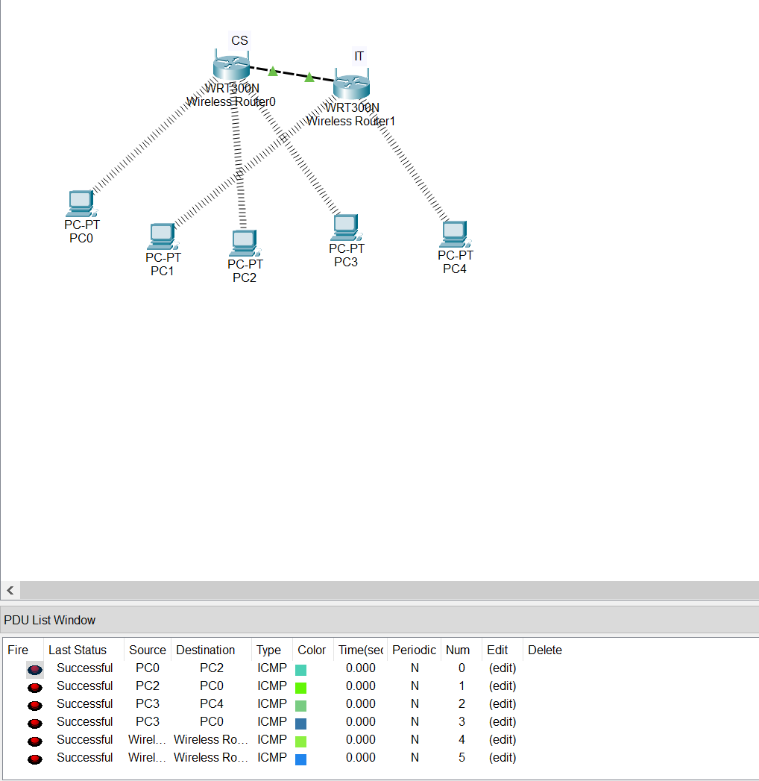

# Practical No: 07

**Aim:** Configuring Basic AP Settings

**Components:** Router, Access points, PC’s

**Theory:** A wireless access point (WAP), or more generally just access point (AP), is a networking hardware device that allows other Wi-Fi devices to connect to a wired network. An access point is a device that creates a wireless local area network, or WLAN, usually in an office or large building.

# Cisco Packet tracer Setup:

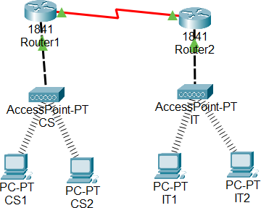

**Step 1:** Arrange all devices as following

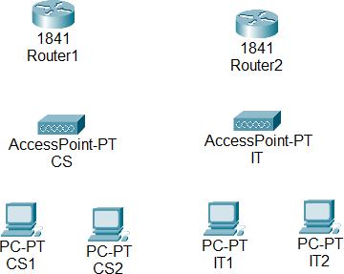

**Step 2:** Configure Access Points (A)



AP-1

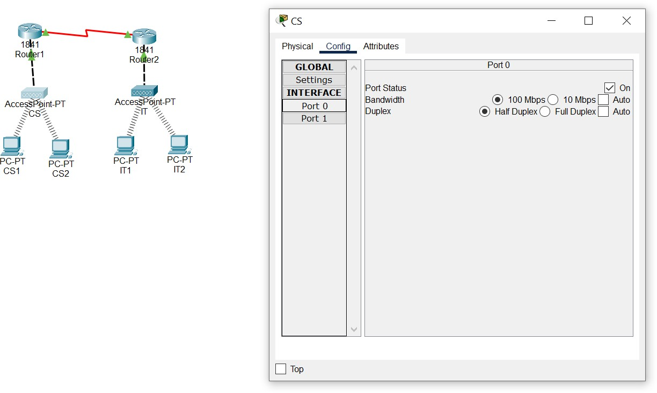

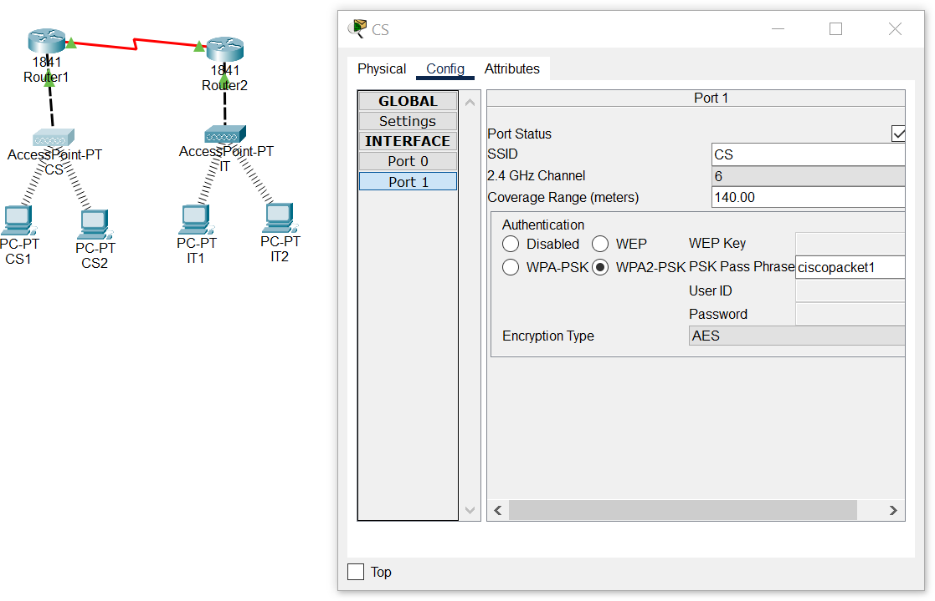

AP-2

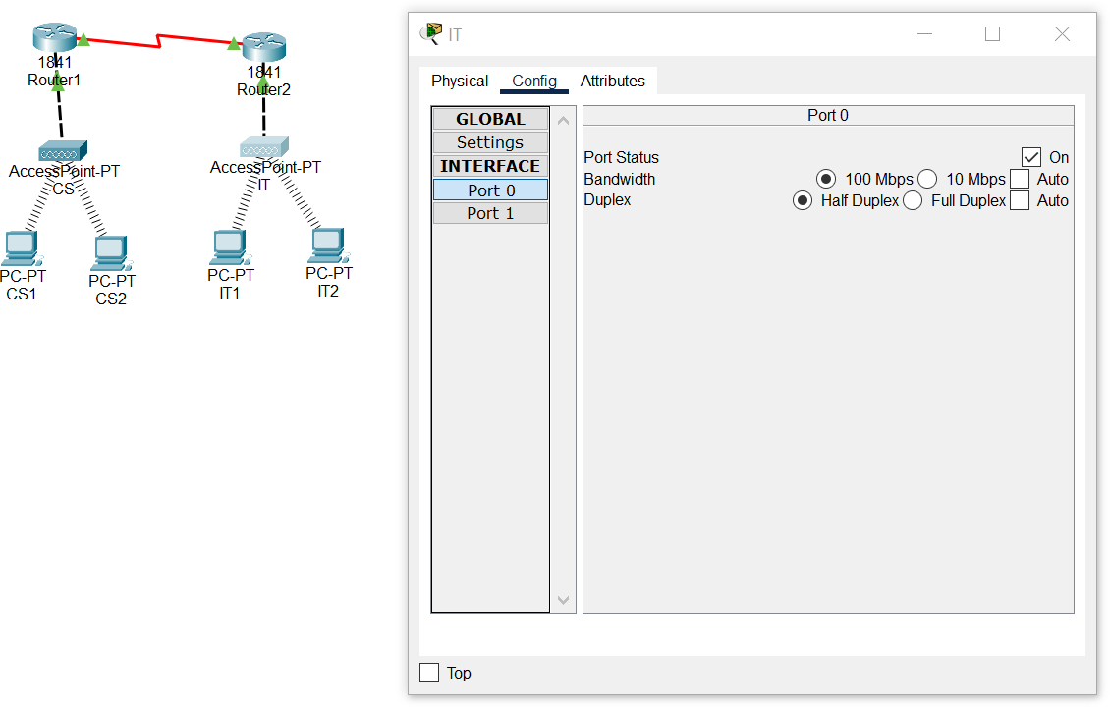

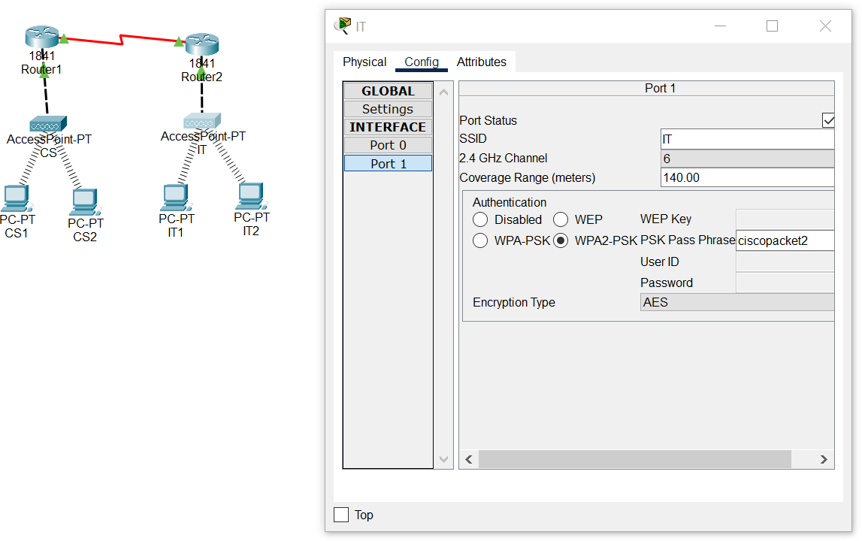

**Step 3:** Configure and Setup IP Address for all devices (PC’s)

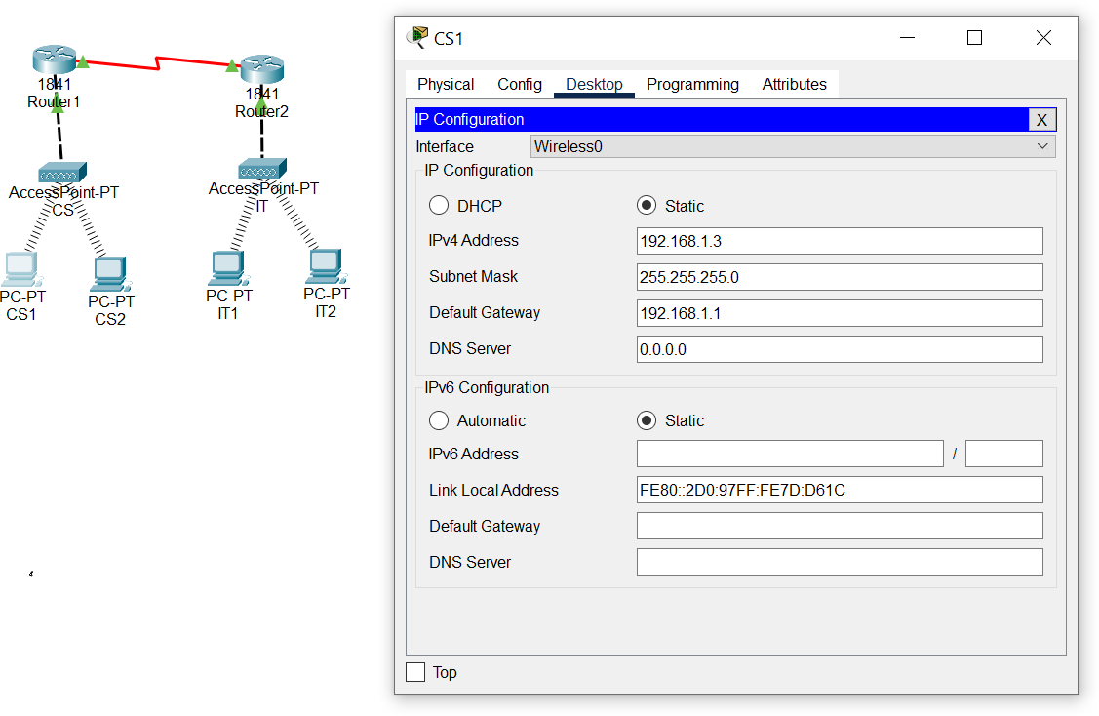

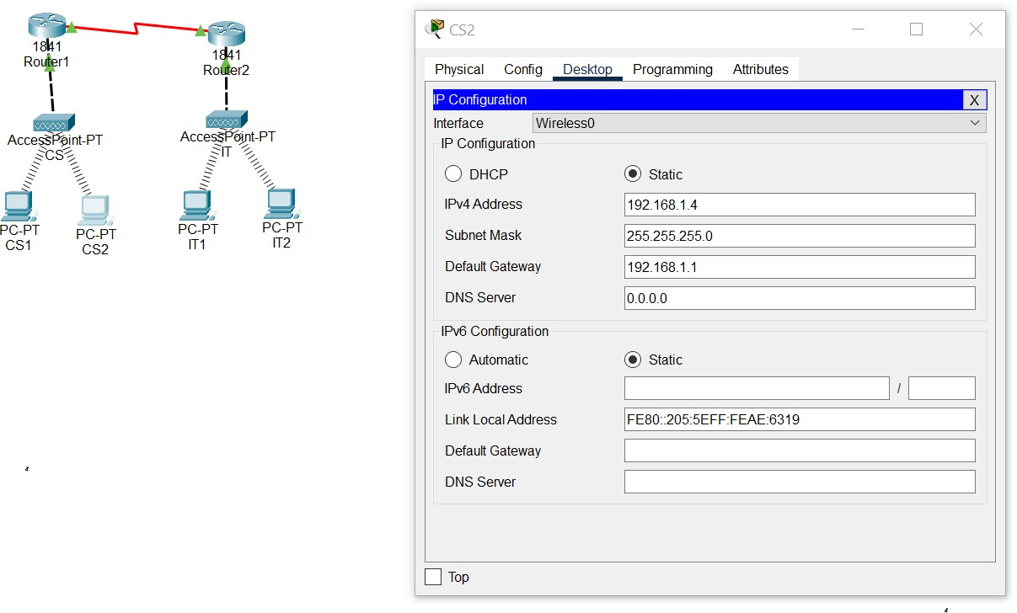

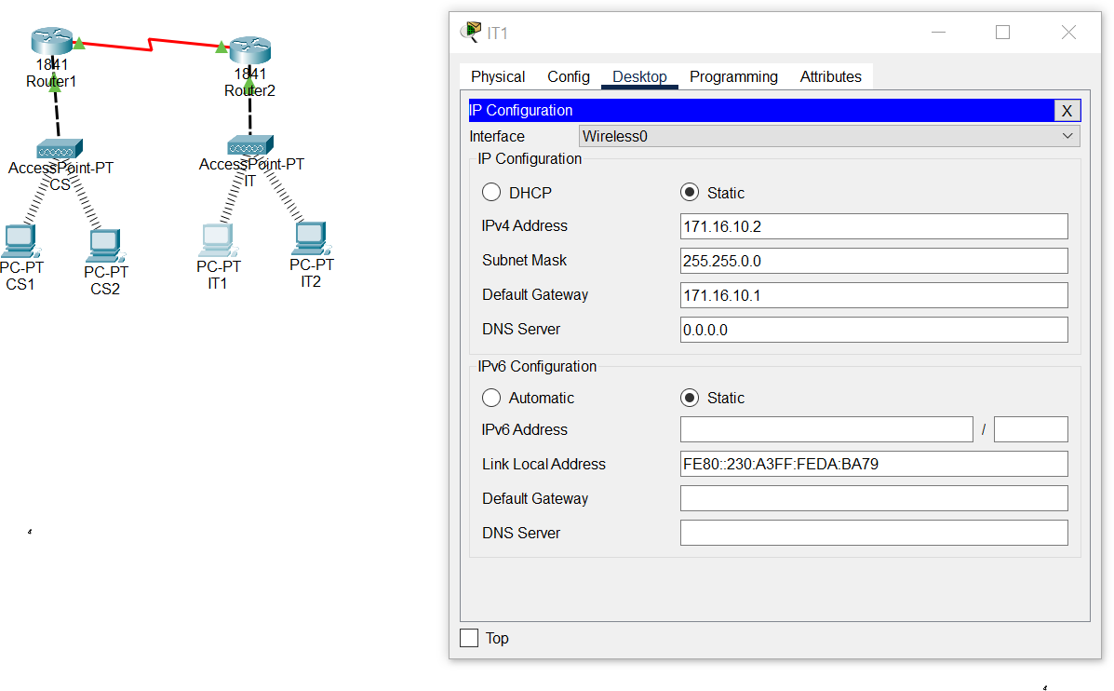

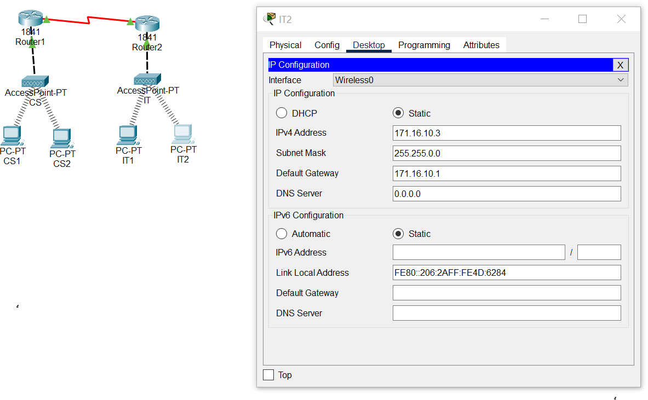

Note: Change all port adapters with wireless adapter for all PC’s

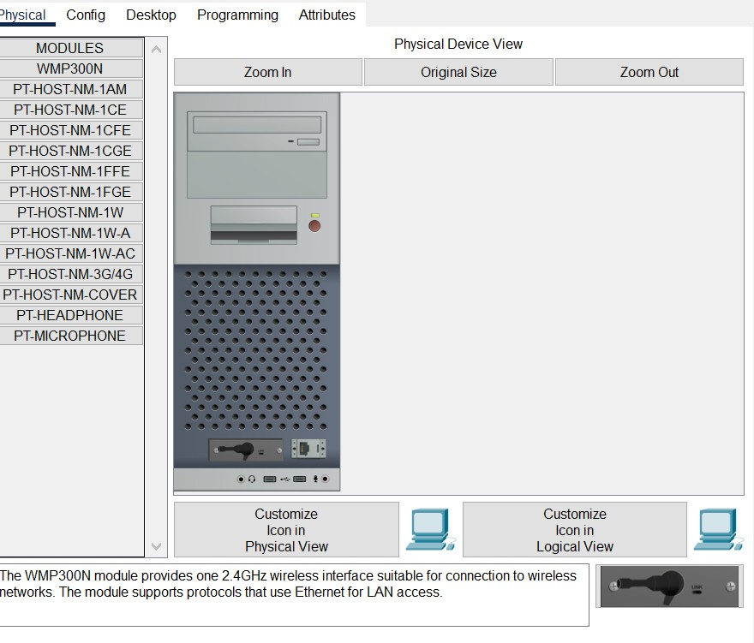

**Step 4:** Configure Access points with PC’s

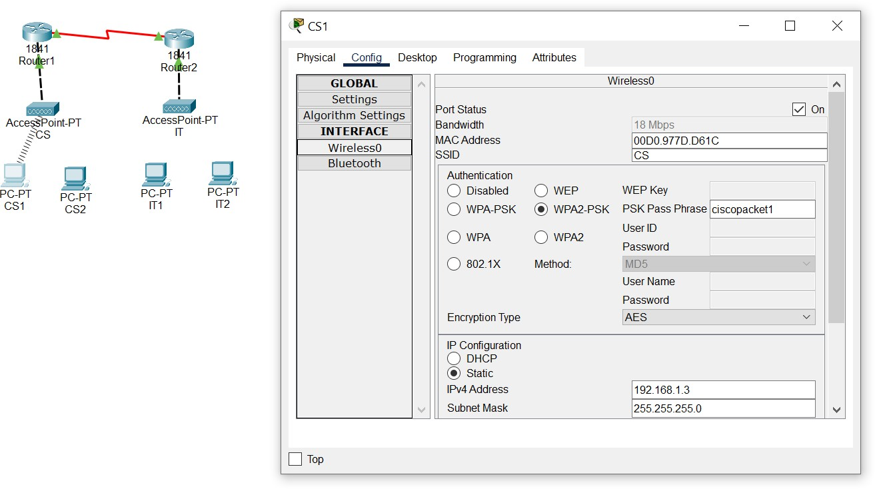

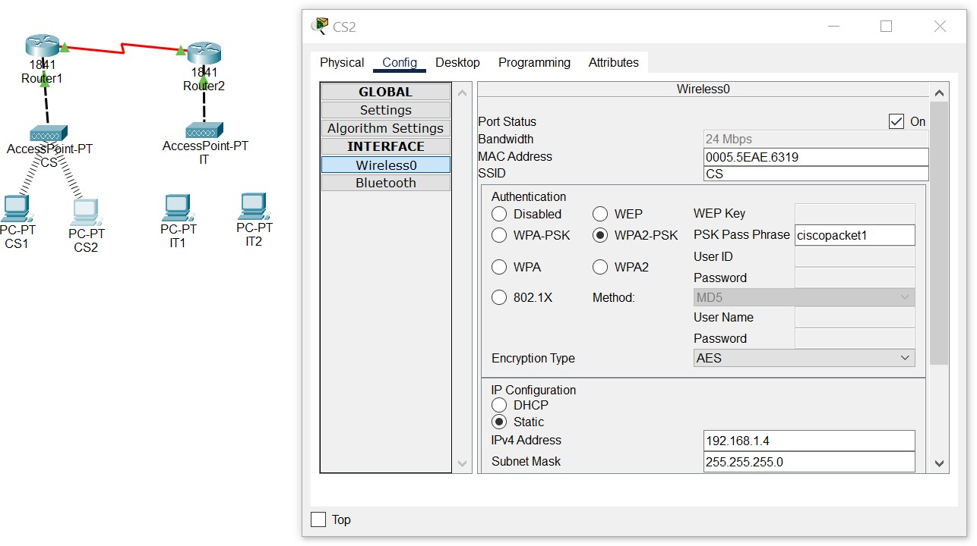

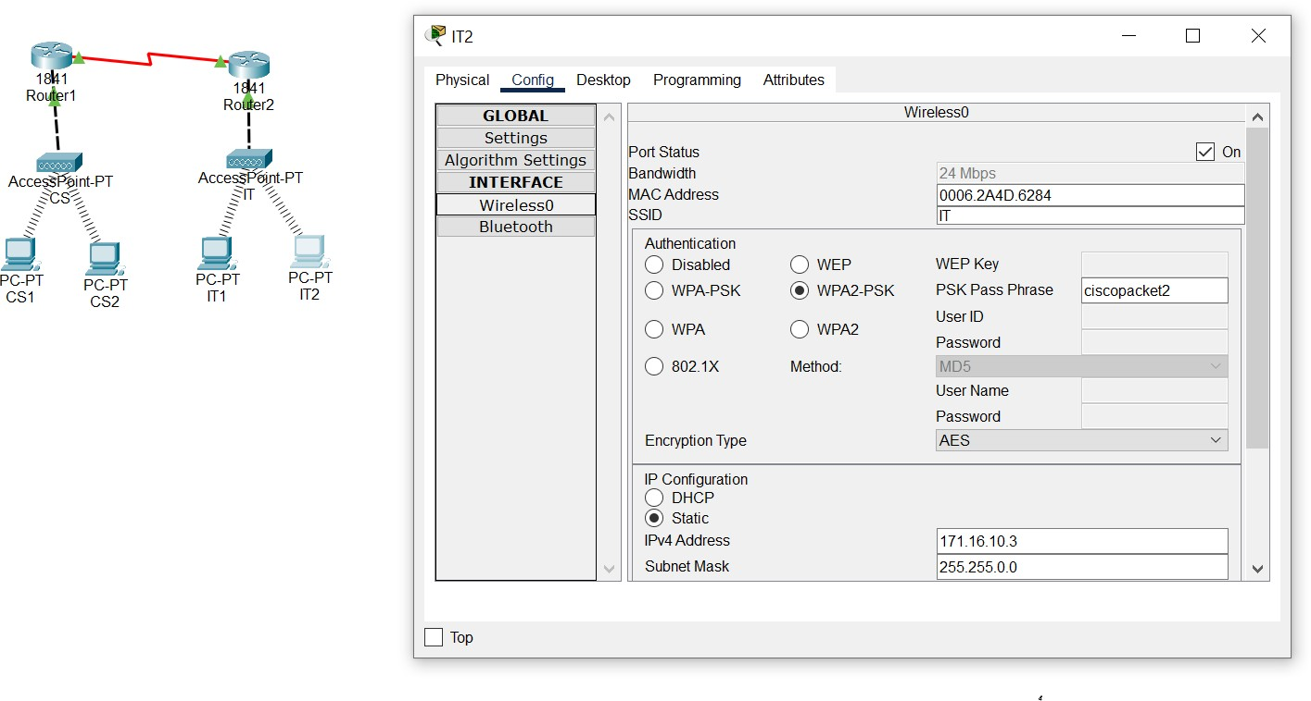

**Step 5:** Connect routers with Access points and configure them

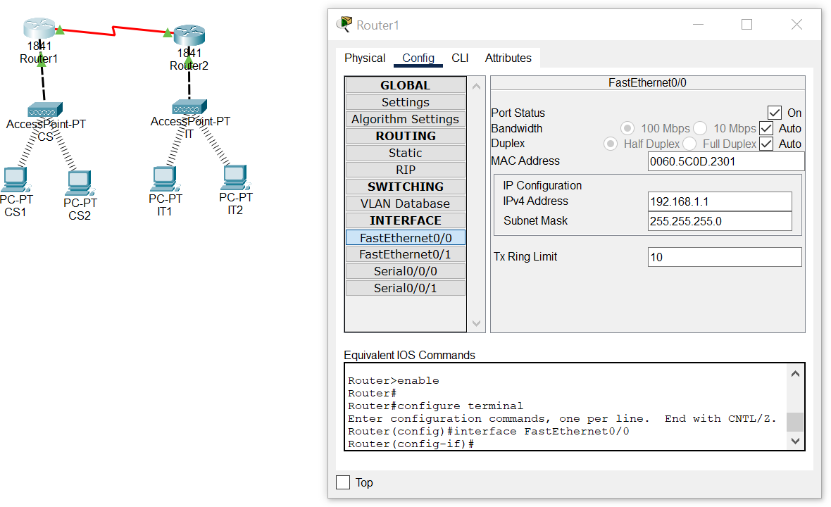

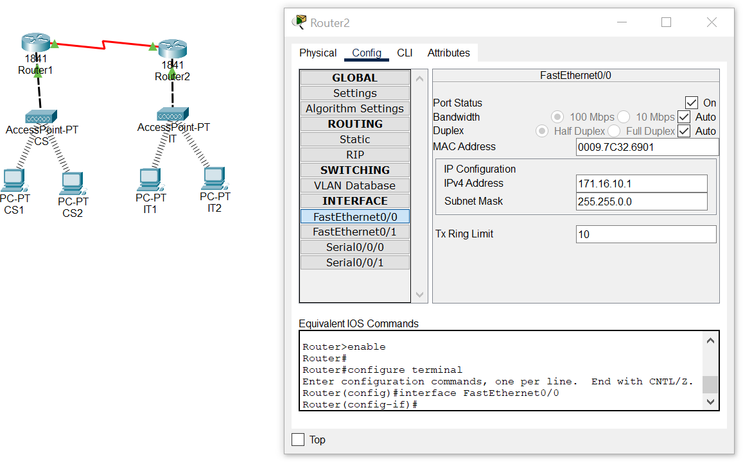

Connect Routers with serial ports and configure

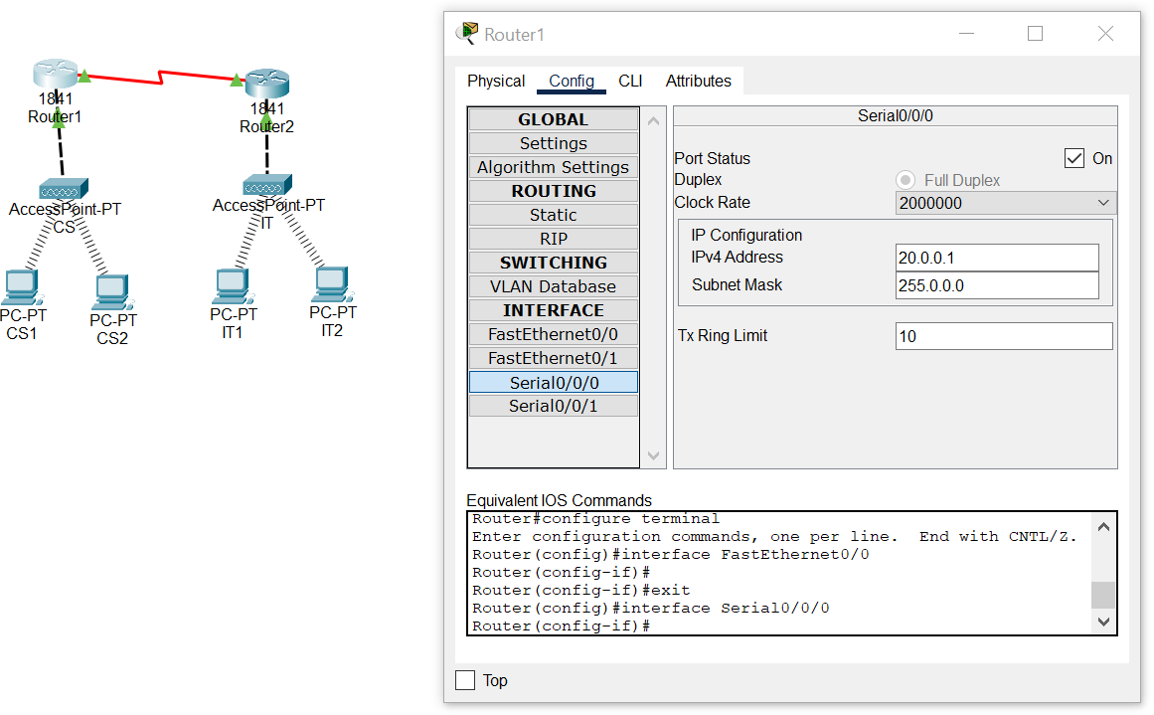

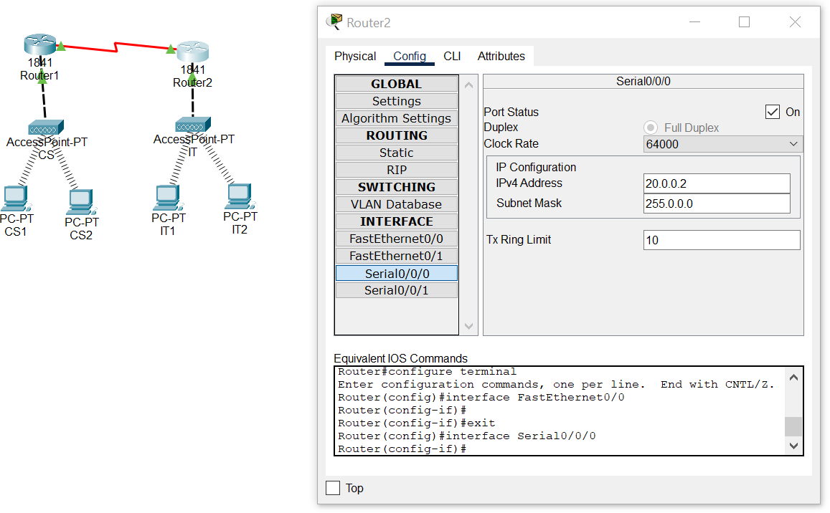

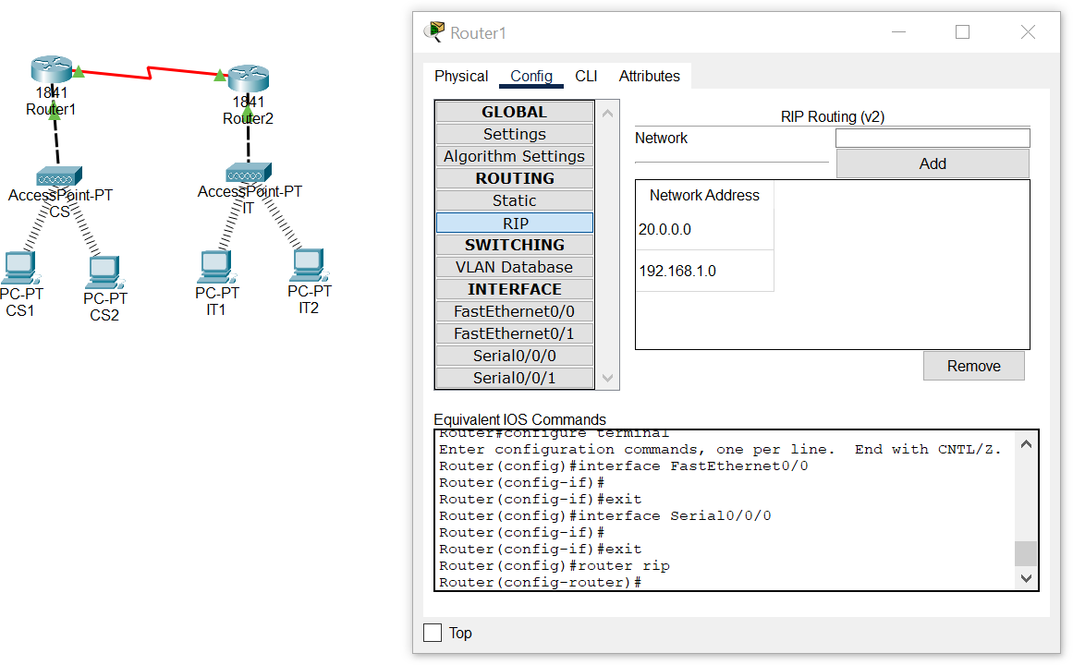

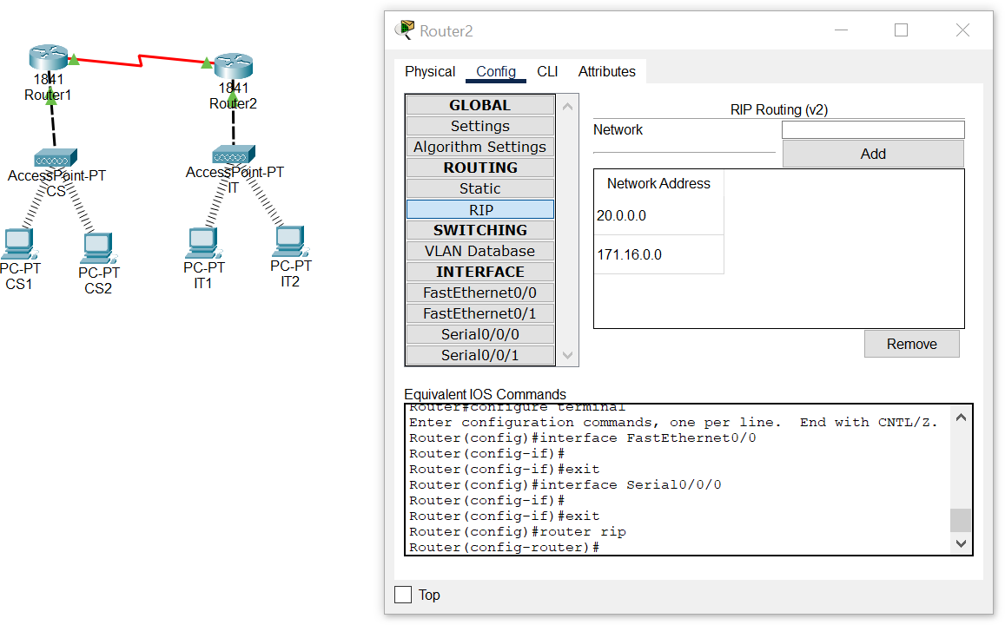

**Step 6:** Check the connection

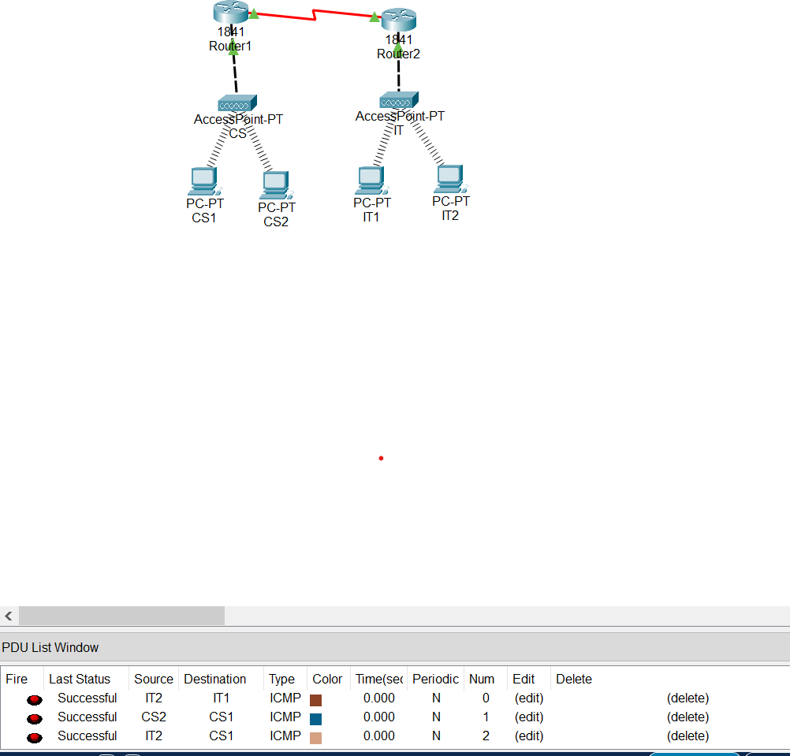

**Practical No: 08 Aim:** Configure fast Ethernet on router using packet tracer **Components:** Router, Switches, PC’s

**Theory:** Fast Ethernet is used for departmental backbones, connections to high-speed servers, and connections to workstations running bandwidth-intensive software such as CAD or multimedia applications.

# Cisco Packet tracer Setup:

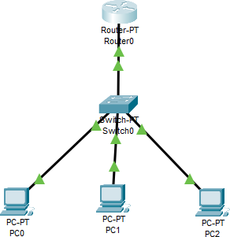

**Step 1:** Arrange all devices

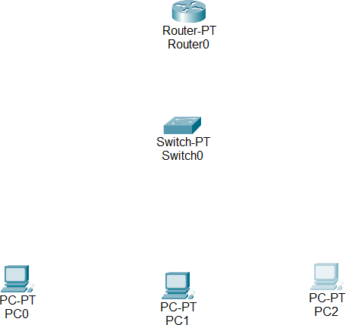

**Step 2:** Connect all devices using Ethernet cable

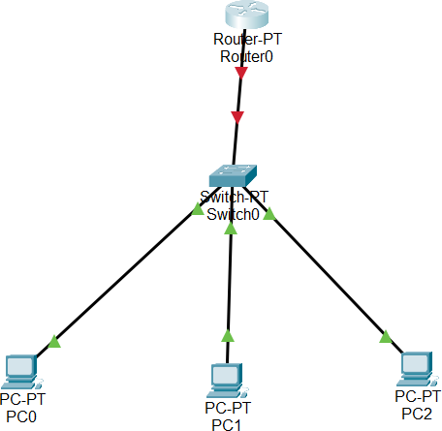

.**Step 3:** Configure Router using CLI Using following commands: configure t

hostname R1

enable password cisco interface fa0/0

ip address 192.168.2.1 255.255.255.0

no shutdown exit

Exit

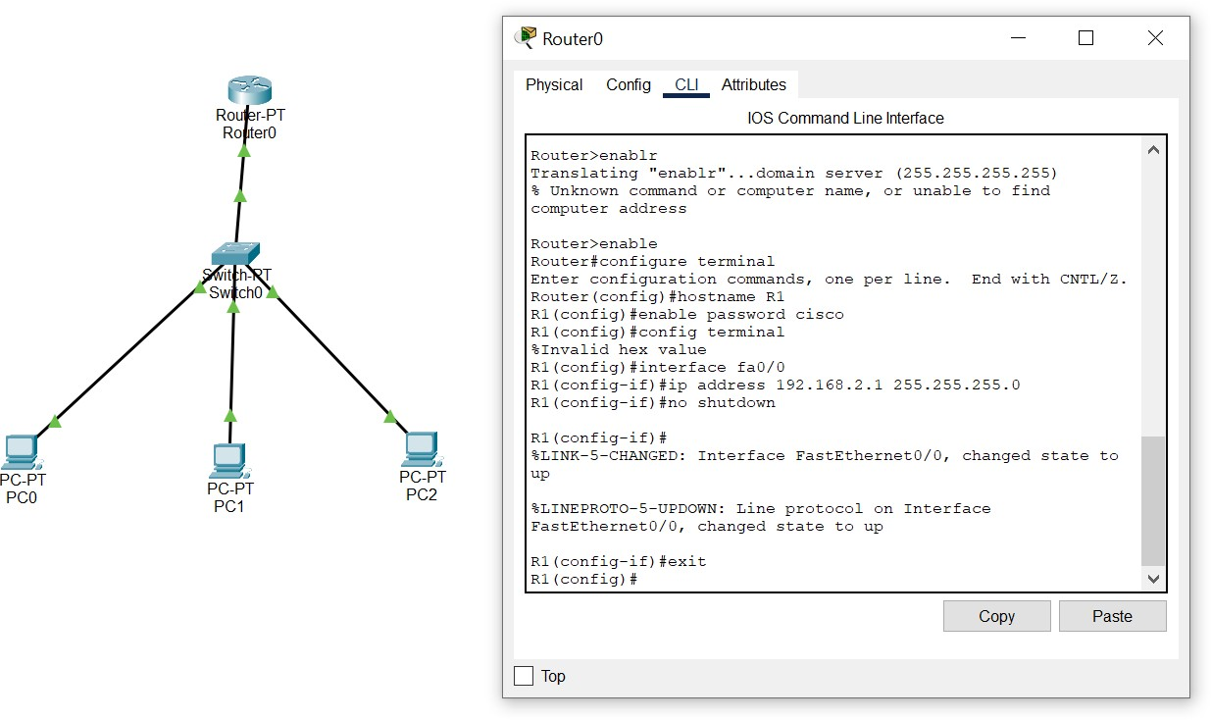

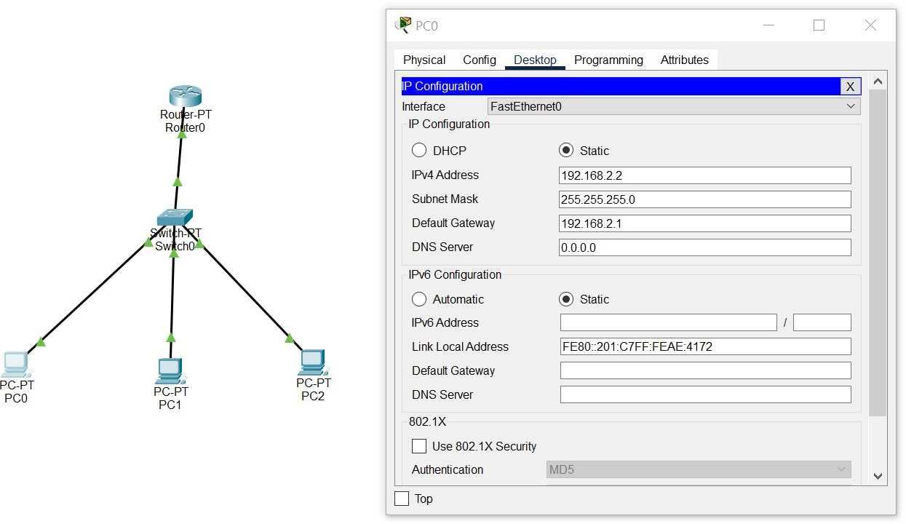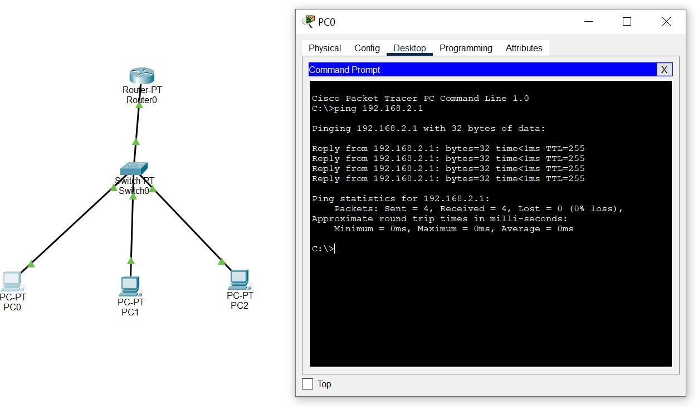**Step 4:** Configure All PC’s and check the connection

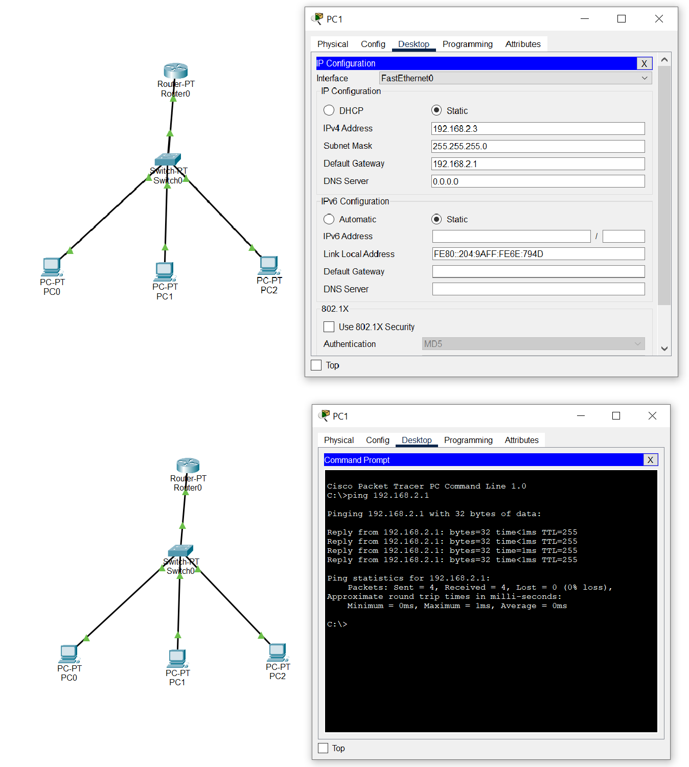

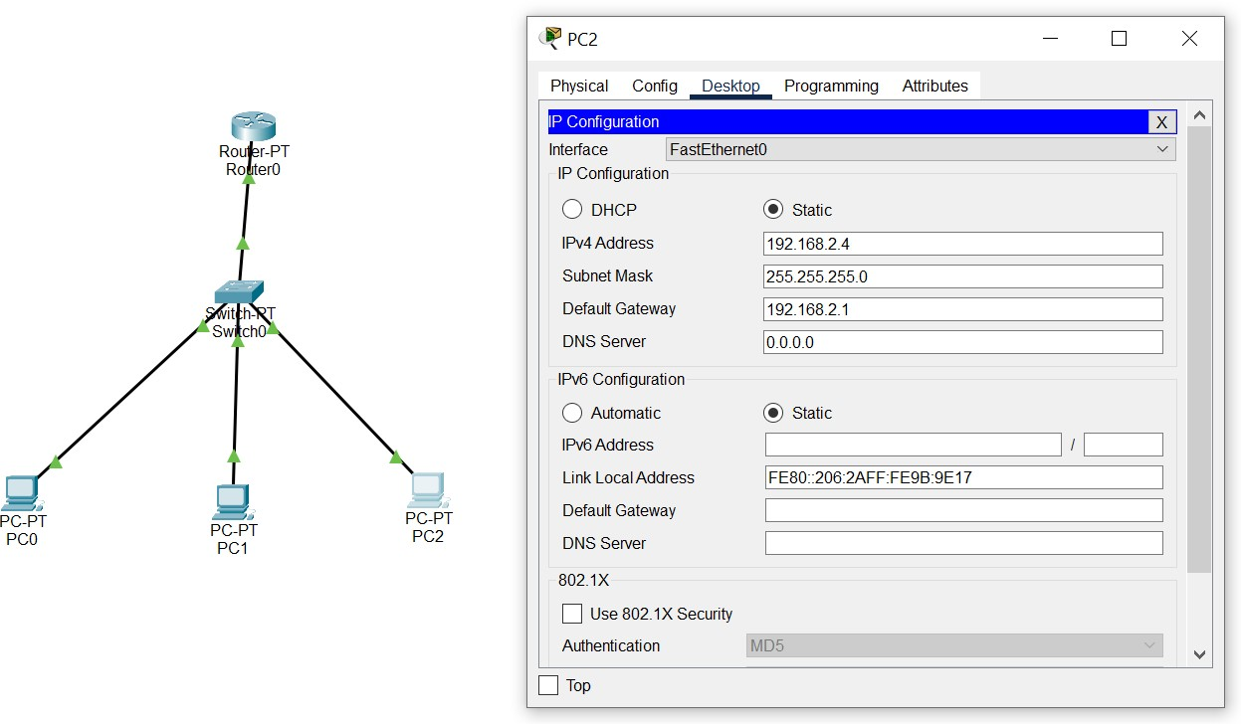

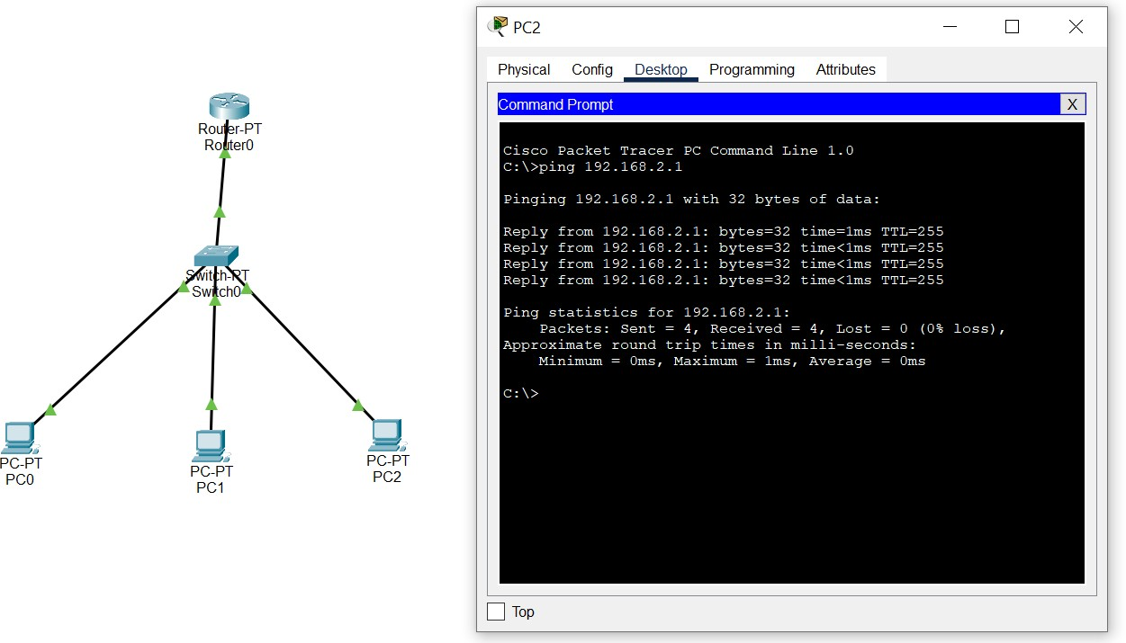

**Step 5:** Check the connection

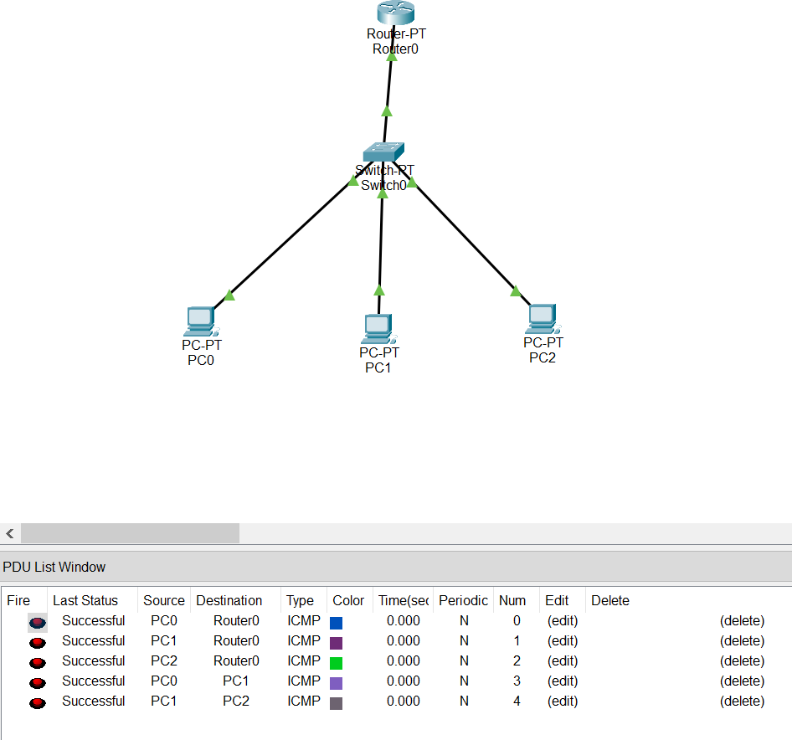

**Practical No: 10 Aim:** Configure Site-to-Site Wireless Link **Components:** Pcs, Routers and Switches

**Theory:** A remote location several miles away requires connectivity to the existing wired network. The two LAN segments will use a wireless bridge for their physical layer connection using two Cisco Aironet Bridges (BR1310s).

# Cisco Packet tracer Setup:

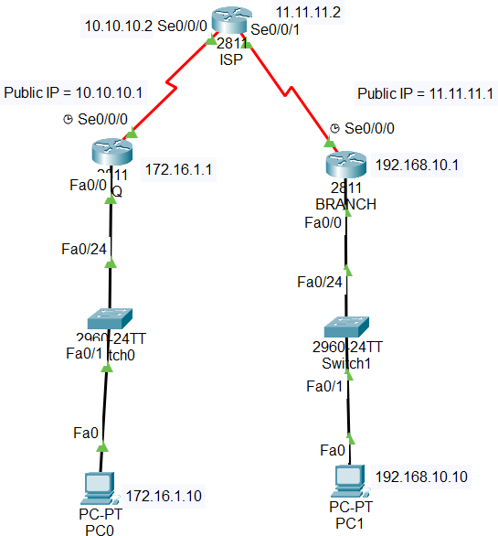

**Step 1: Assign to all the Router**

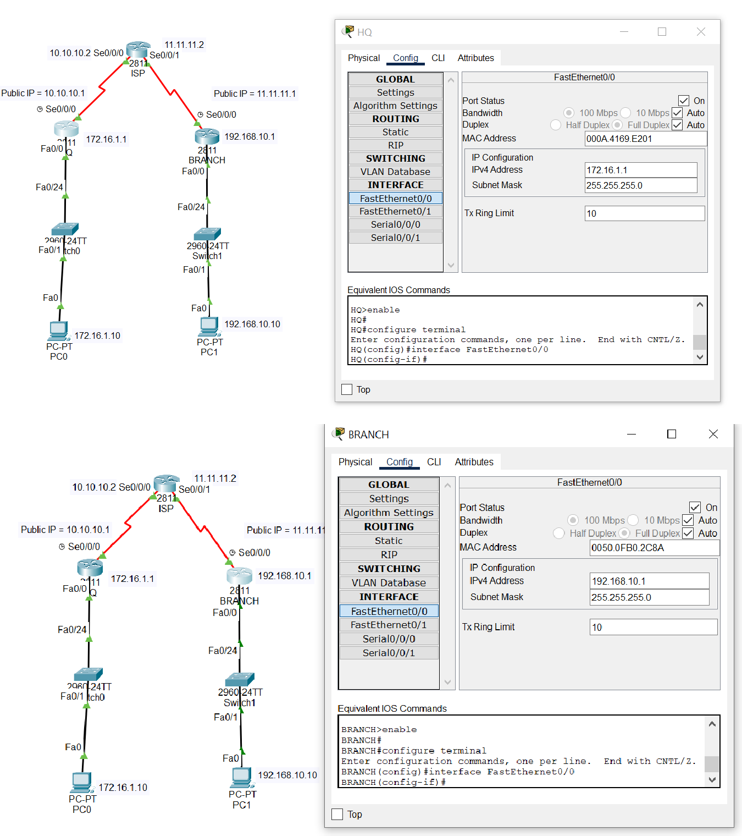

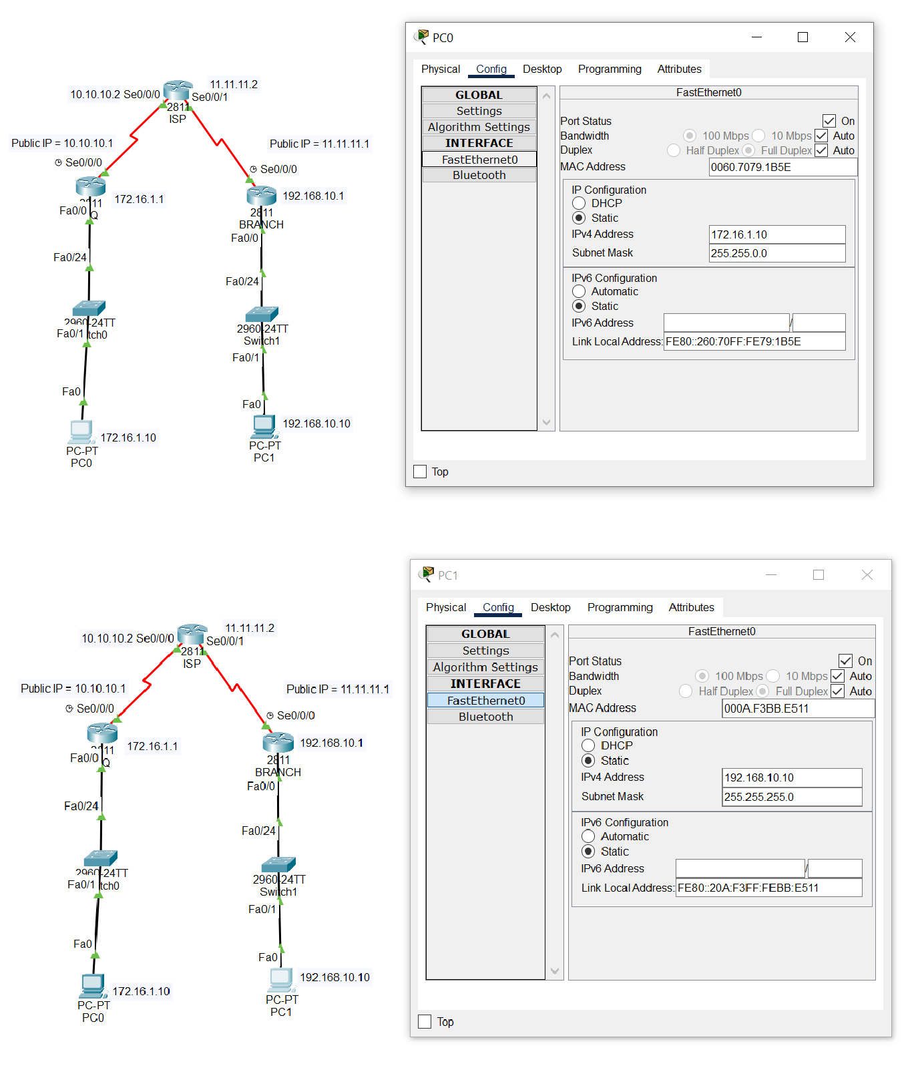

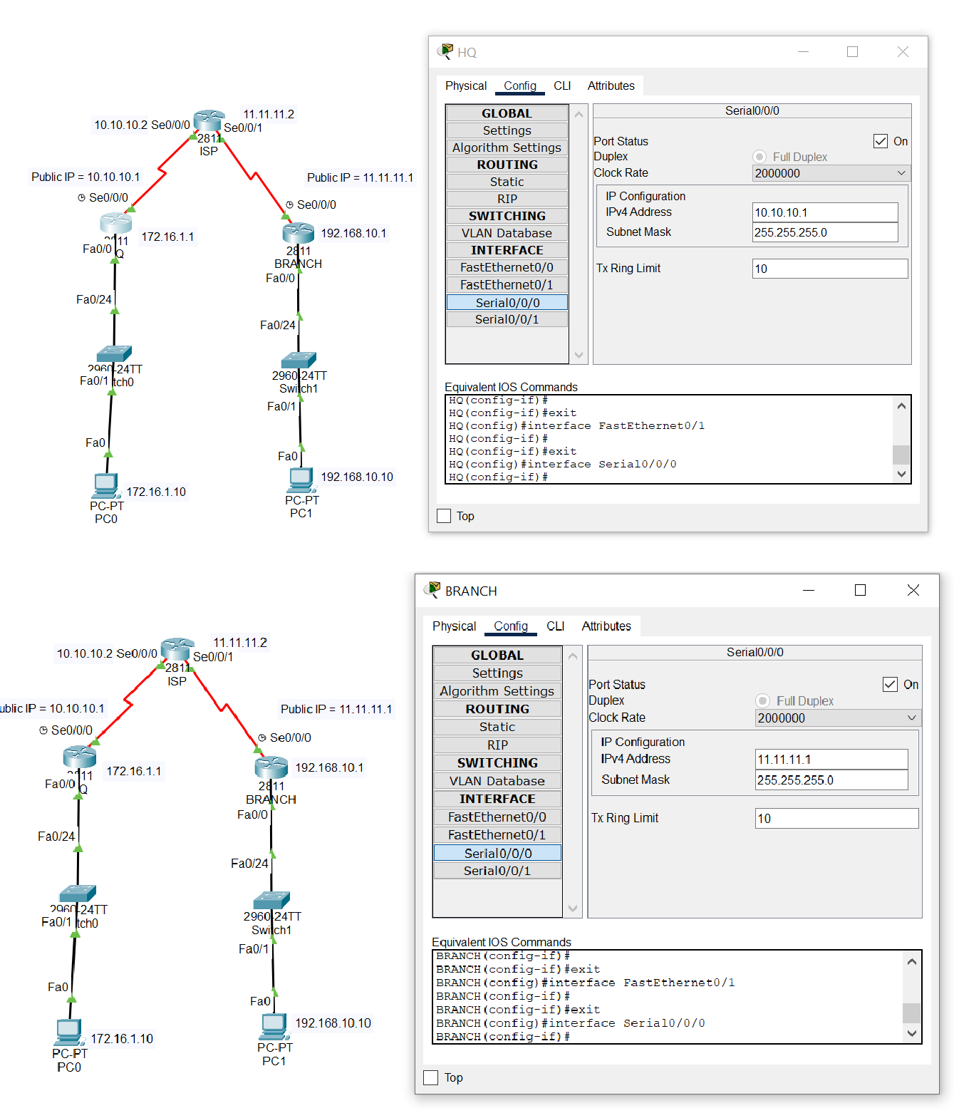

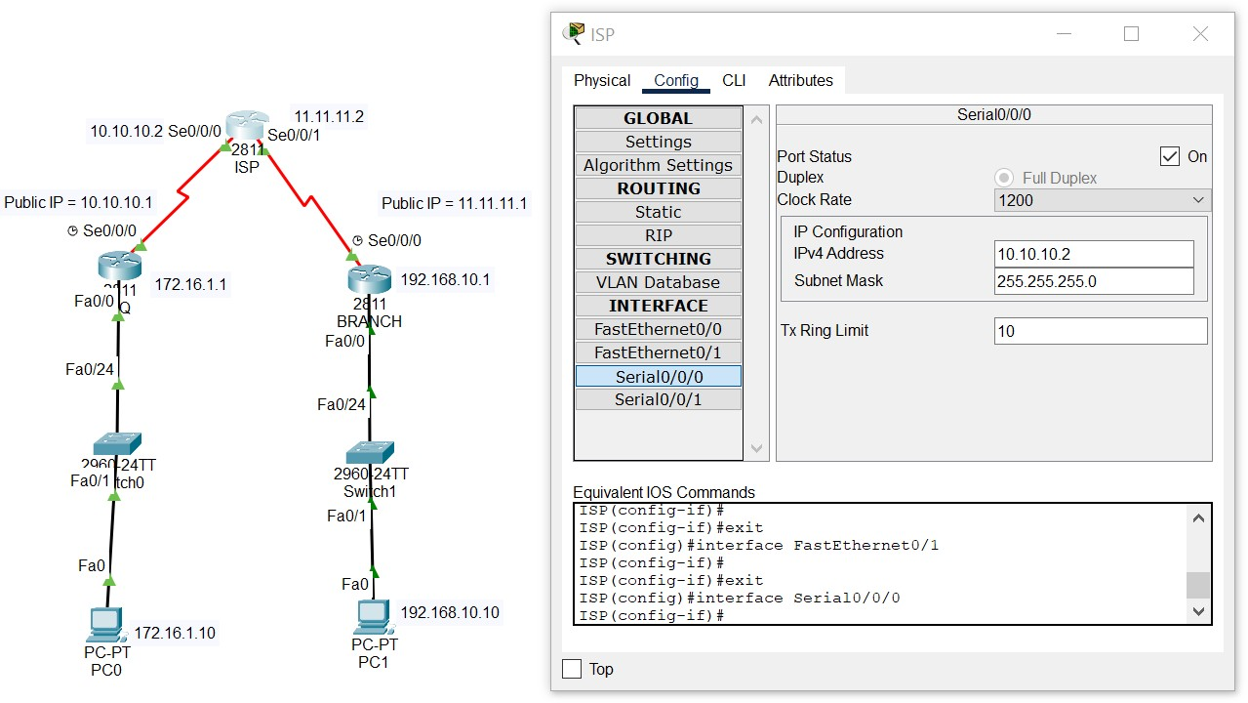

# Step 2: Configure Default Router on HQ and BRANCH and static Router from ISP

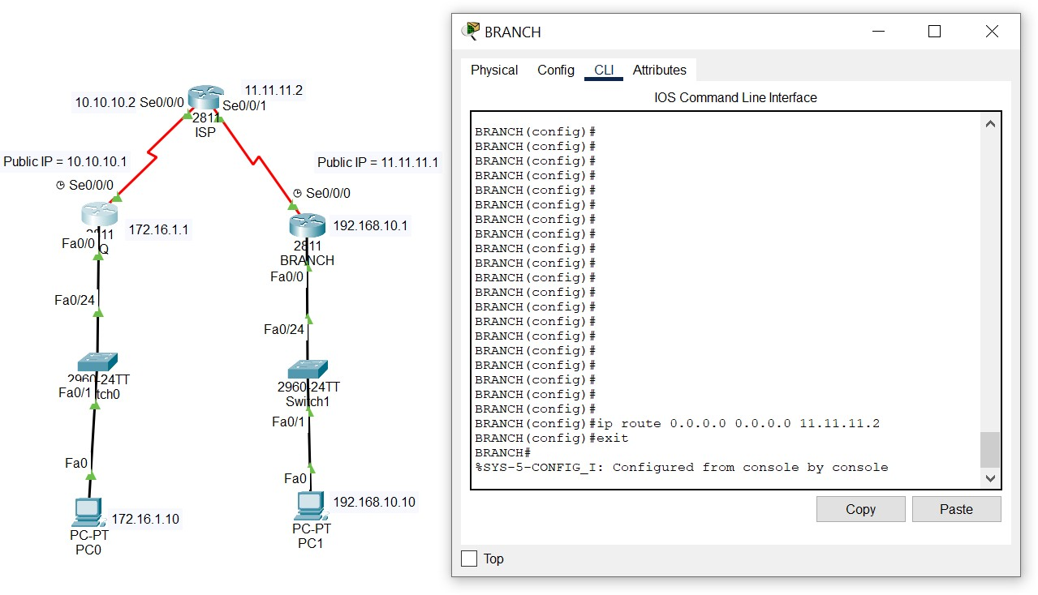

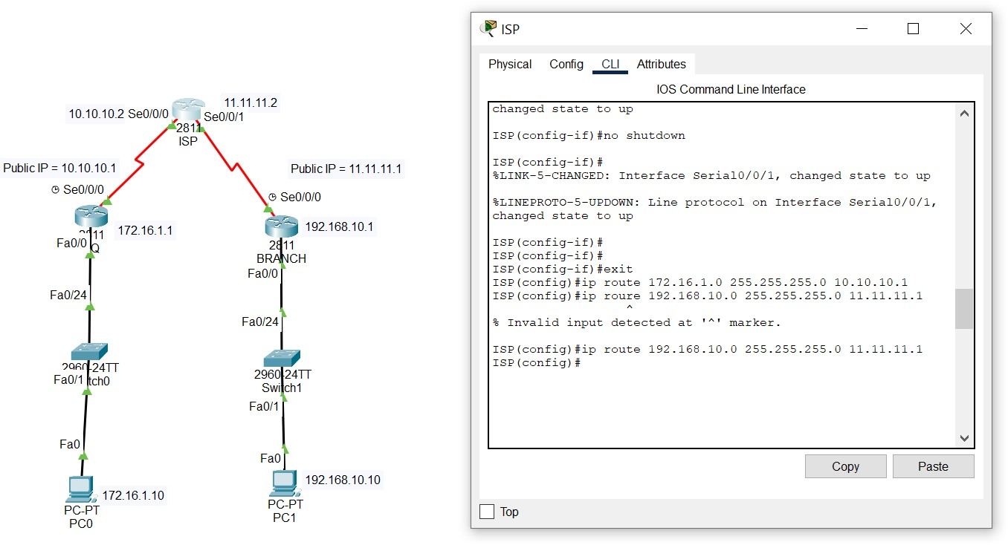

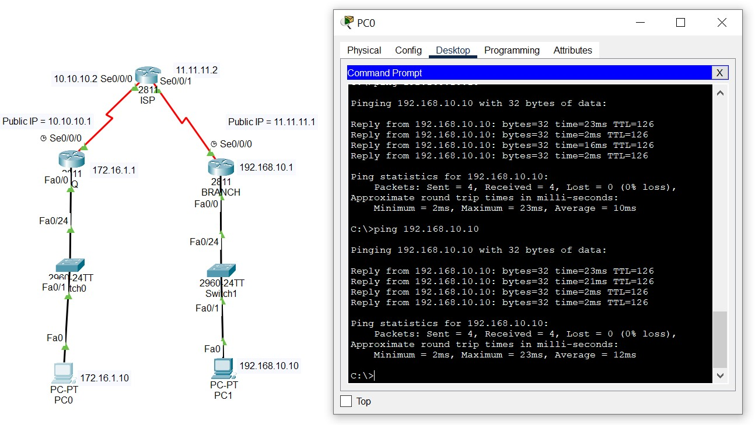

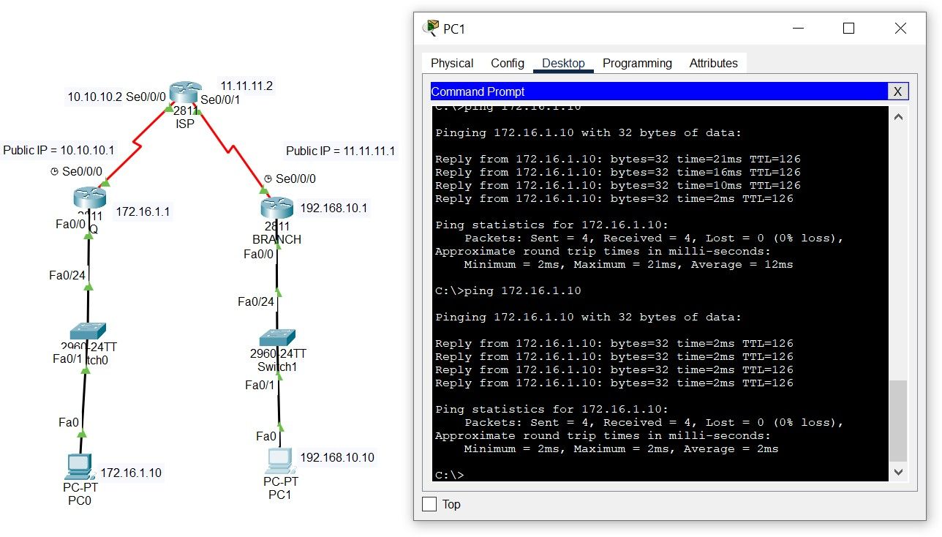

**Step 3: Configure VP site to site**

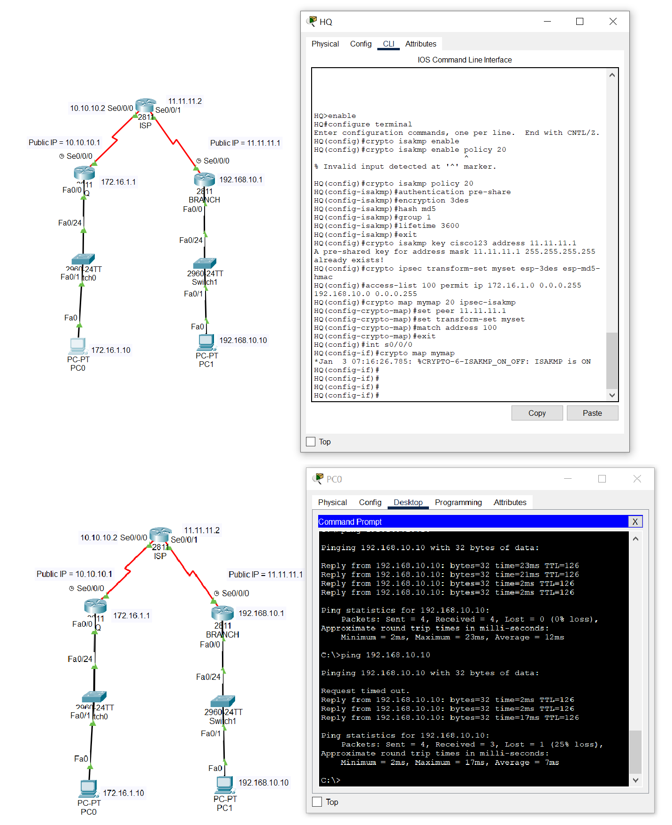

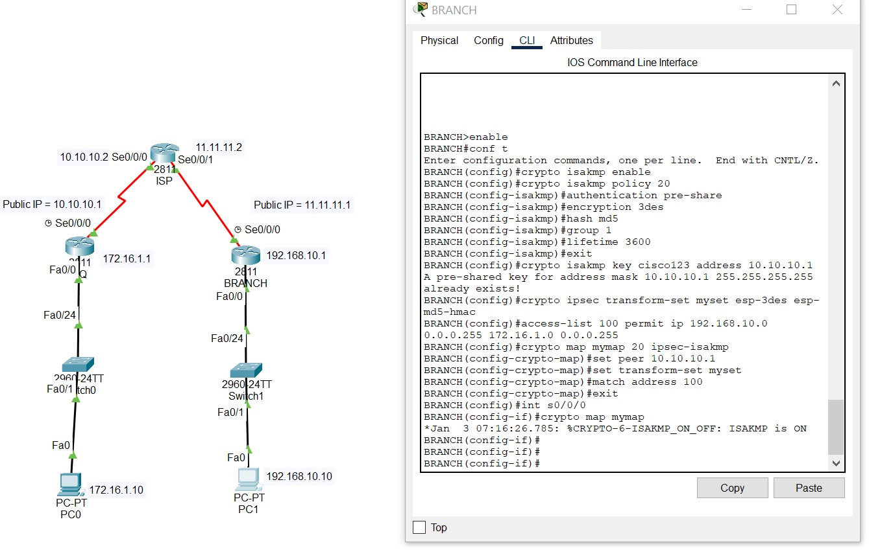

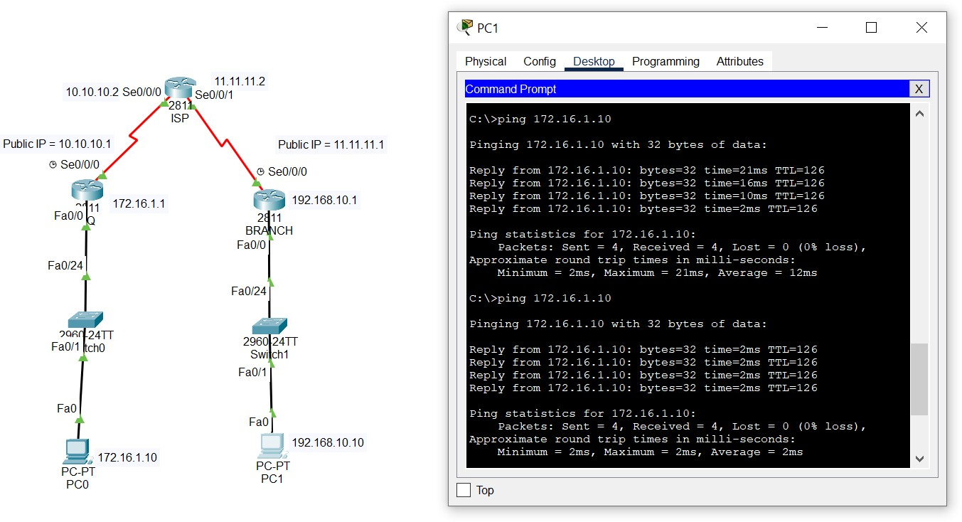

# Step 4: Testing and Verify VPN

